Statistical Test Result #192 — Analysis Report
Generated 2026-09-21 02:38:50 · 1 run(s) · CAT-G Data Analyzer

1. morans i (#192)
2026-09-21 02:17:40 · statistical_test · status: completed
The morans i on value was statistically significant (p = 0.001).
Metric | Value
i_statistic | 0.93426
expected_i | -0.010101
p_value | 0.001
n | 100
n_perm | 999
k | 4
interpretation | Significant positive spatial autocorrelation: similar values cluster together.
lat_col | lat
long_col | long
value_col | value
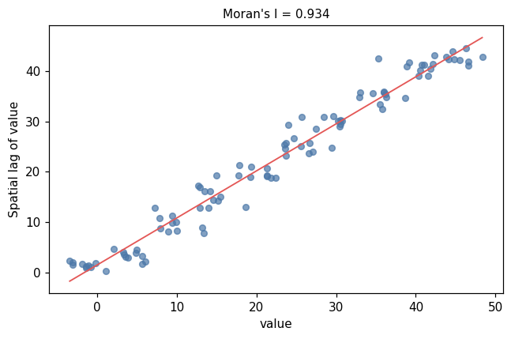
moran scatter
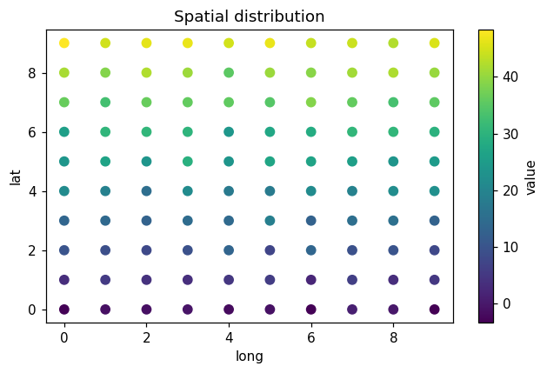
moran map

Method & Provenance
Metric | Value
method | Moran's I spatial autocorrelation
engine | Python · scipy 1.17.1
datasets | gallery — example_spatial.csv
started | 2026-09-21 02:17:40.060293
permanent link | https://cat-g-omxpert.wishartlab.com/results/by-token/66614358074645c98395b216a4924710
Parameter | Value
test_type | morans_i
value_col | value
lat_col | lat
long_col | long
n_perm | 999

Command history
# python
# app.services.spatial_service.morans_i (distance-decay weights)
# python
I, p = morans_i(values, latitudes, longitudes)

