Random Forest Result #151 — Analysis Report
Generated 2026-09-21 02:38:56 · 1 run(s) · CAT-G Data Analyzer

1. random forest (#151)
2026-09-21 02:17:48 · random_forest · status: completed
The model explains 0.0% of the variance in the target — worse than simply predicting the mean; treat predictions as unreliable.
Metric | Value
task_type | regression
r2_mean | -0.5783
r2_std | 0.617272
mse_mean | 3.519505
mse_std | 1.086945

permutation importance
name | mean | std
Protein_A01 | 0.013745 | 0.033767
Protein_B02 | -0.014693 | 0.036506
Protein_C03 | 0.168846 | 0.143659
Protein_D04 | -0.01372 | 0.008411
Protein_E05 | -0.082587 | 0.089068
Protein_F06 | 0.194496 | 0.264982
Protein_G07 | 0.114167 | 0.171214
Protein_H08 | 0.008102 | 0.009232
Protein_I09 | 0.192246 | 0.164957
Protein_J10 | 0.171206 | 0.182525

shap importance
name | mean_abs
Protein_A01 | 0.104572
Protein_B02 | 0.036776
Protein_C03 | 0.247165
Protein_D04 | 0.018802
Protein_E05 | 0.030457
Protein_F06 | 0.434281
Protein_G07 | 0.218849
Protein_H08 | 0.023725
Protein_I09 | 0.248877
Protein_J10 | 0.263879

split metrics
r2 | mse
-0.958022 | 4.947417
0.292293 | 3.298471
-1.069172 | 2.312626
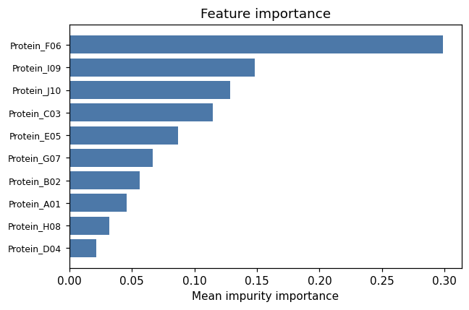
importance bar
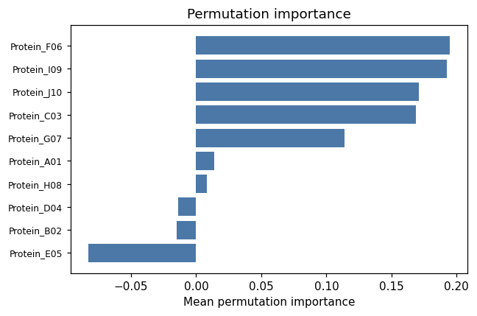
permutation bar
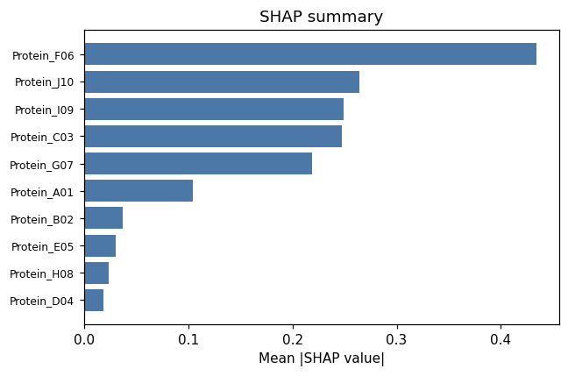
shap summary
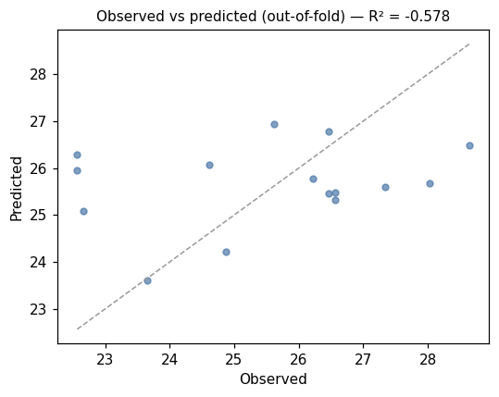
pred vs obs
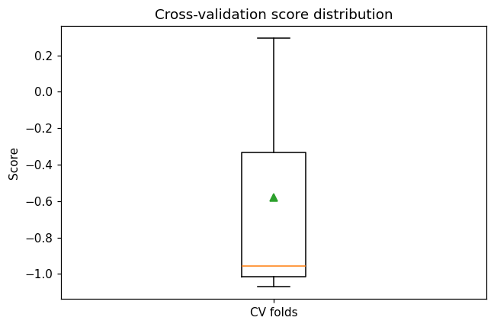
cv boxplot

Method & Provenance
Metric | Value
method | Random Forest (Regression)
engine | Python · scikit-learn 1.8.0
datasets | gallery — example_proteomics.csv
started | 2026-09-21 02:17:48.827397
permanent link | https://cat-g-omxpert.wishartlab.com/results/by-token/a55dc899cd514343aea98c71daeb65ee
Parameter | Value
task_type | regression
model_type | regression
target_column | Protein_content
n_estimators | 60
n_splits | 3
test_size | 0.25
run_univariate | True
run_permutation | True
run_shap | True
permutation_repeats | 10
fdr_threshold | 0.05

Command history
# python
from sklearn.ensemble import RandomForestRegressor
# python
model = RandomForestRegressor(n_estimators=60, random_state=42)
# python
scores = sklearn.model_selection.cross_val_score(model, X, y, cv=3)

