Pathway Result #47 — Analysis Report
Generated 2026-09-21 02:39:00 · 1 run(s) · CAT-G Data Analyzer

1. pathway (#47)
2026-09-21 02:17:58 · pathway · status: completed
Enrichment analysis found 125 significant term(s) across the queried databases.

go
go_id | go_term | namespace | gene_count | bg_count | gene_ratio | bg_ratio | p_value | fdr | genes
GO:0006355 | regulation of DNA-templated transcription | biological_process | 16 | 16 | 0.64 | 0.444444 | 0.00028 | 0.034945 | ['AGL24', 'AP1', 'CDF1', 'COL1', 'FD', 'FKF1', 'FUL', 'FWA', 'GI', 'LFY', 'LHY', 'PHYB', 'SOC1', 'SPL3', 'SVP', 'TOC1']
GO:0009911 | positive regulation of flower development | biological_process | 9 | 9 | 0.36 | 0.25 | 0.021701 | 0.694444 | ['CRY2', 'FD', 'FKF1', 'FT', 'FUL', 'FWA', 'SOC1', 'SPL3', 'TSF']
GO:0007623 | circadian rhythm | biological_process | 8 | 8 | 0.32 | 0.222222 | 0.035742 | 0.694444 | ['CCA1', 'COL1', 'CRY2', 'FKF1', 'GI', 'LHY', 'TOC1', 'ZTL']
GO:0009908 | flower development | biological_process | 6 | 6 | 0.24 | 0.166667 | 0.090923 | 0.694444 | ['AP1', 'GI', 'LFY', 'SOC1', 'SPL3', 'ZTL']
GO:0009909 | regulation of flower development | biological_process | 6 | 6 | 0.24 | 0.166667 | 0.090923 | 0.694444 | ['COL1', 'CRY2', 'FD', 'FT', 'FWA', 'LFY']
GO:2000028 | regulation of photoperiodism, flowering | biological_process | 6 | 6 | 0.24 | 0.166667 | 0.090923 | 0.694444 | ['COL1', 'CRY2', 'FD', 'GI', 'LHY', 'PHYB']
GO:0045893 | positive regulation of DNA-templated transcription | biological_process | 6 | 6 | 0.24 | 0.166667 | 0.090923 | 0.694444 | ['AGL24', 'AP1', 'CCA1', 'FD', 'SOC1', 'SPL3']
GO:0006357 | regulation of transcription by RNA polymerase II | biological_process | 5 | 5 | 0.2 | 0.138889 | 0.140931 | 0.694444 | ['AGL24', 'AP1', 'FUL', 'SOC1', 'SVP']
GO:0045944 | positive regulation of transcription by RNA polymerase II | biological_process | 5 | 5 | 0.2 | 0.138889 | 0.140931 | 0.694444 | ['AGL24', 'AP1', 'FUL', 'SOC1', 'SVP']
GO:0009637 | response to blue light | biological_process | 5 | 5 | 0.2 | 0.138889 | 0.140931 | 0.694444 | ['CRY2', 'FKF1', 'GI', 'LHY', 'ZTL']
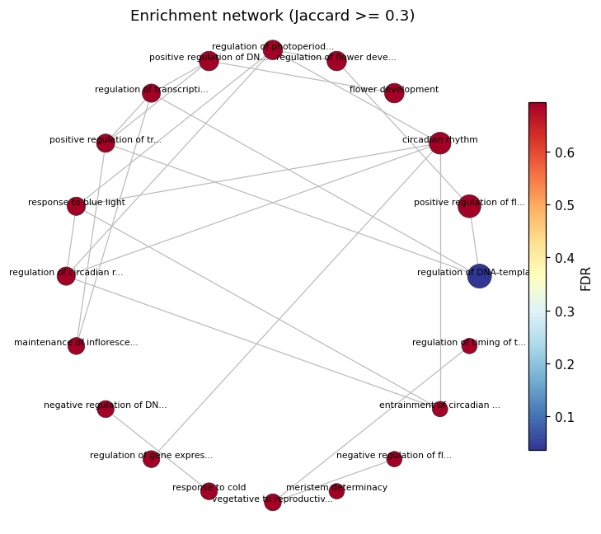
enrichment network
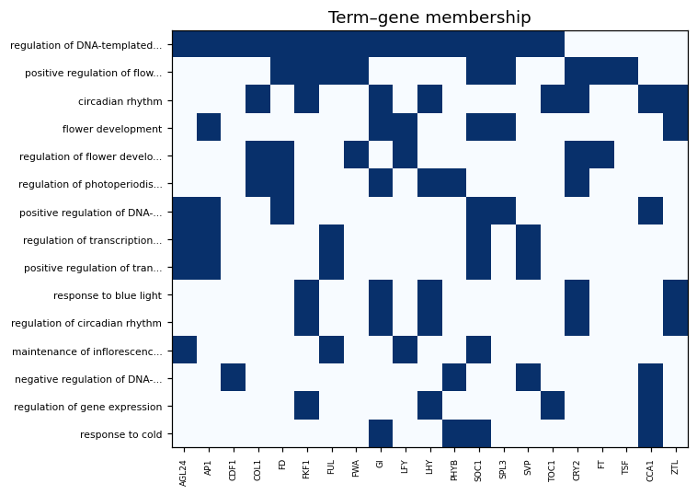
term gene heatmap

Method & Provenance
Metric | Value
method | Pathway enrichment — GO/KEGG/GSEA
engine | Python · scipy/gseapy 1.17.1
datasets | gallery — example_proteomics.csv
started | 2026-09-21 02:17:58.014941
permanent link | https://cat-g-omxpert.wishartlab.com/pathway/results/by-token/fcbf2775619240969f9aed1551730c97
Parameter | Value
organism | arabidopsis
namespace | biological_process
min_gene_count | 1
n_input_genes | 25
fdr_threshold | 0.05

Command history
# python
# GO/KEGG enrichment: hypergeometric test per term
# python
from scipy.stats import hypergeom
# python
p = hypergeom.sf(k - 1, N_background, K_term, n_input)
# python
fdr = statsmodels.stats.multitest.multipletests(p_values, method='fdr_bh')
# python
# GSEA: gseapy.prerank(rnk=ranked_genes, gene_sets=gmt, seed=seed)

