Ordination Result #53 — Analysis Report
Generated 2026-09-21 02:38:28 · 1 run(s) · CAT-G Data Analyzer

1. pcoa (#53)
2026-09-21 02:17:05 · ordination · status: completed
The first two PCOA axes capture 40.2% of the total variance in the data.
Metric | Value
stress | 1571.47598
metric | braycurtis
n_components | 3
method | pcoa
n_rows | 80
n_dropped | 0
color_col | gradient

explained variance
Axis | Fraction | Cumulative
Axis 1 | 0.284662 | 0.284662
Axis 2 | 0.117255 | 0.401917
Axis 3 | 0.095184 | 0.497101
Axis 4 | 0.084368 | 0.581468
Axis 5 | 0.059372 | 0.64084
Axis 6 | 0.047123 | 0.687963
Axis 7 | 0.042133 | 0.730096
Axis 8 | 0.031862 | 0.761958
Axis 9 | 0.029184 | 0.791142
Axis 10 | 0.023131 | 0.814273
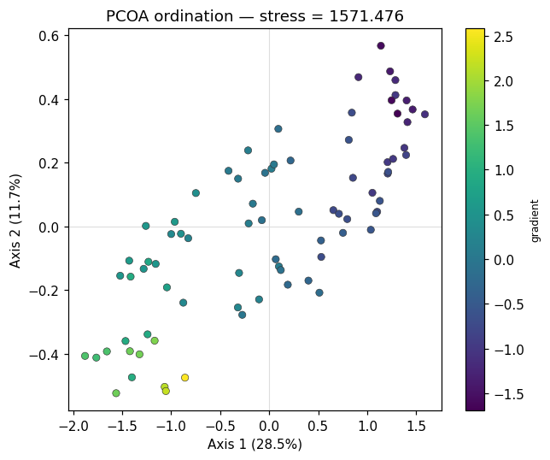
ordination scatter
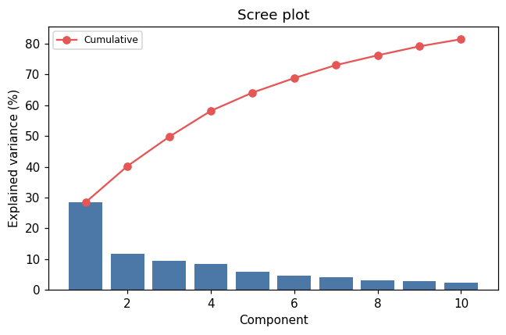
scree

Method & Provenance
Metric | Value
method | Ordination — PCoA
engine | Python · scikit-learn 1.8.0
datasets | gallery — example_ordination.csv
started | 2026-09-21 02:17:05.684714
permanent link | https://cat-g-omxpert.wishartlab.com/results/by-token/e7a09c01ffc64b94910ff6cb8319a426
Parameter | Value
ordination_method | pcoa
method | pcoa
feature_cols | gradient, f1, f2, f3, f4, f5, f6, f7, f8
n_components | 3
color_col | gradient

Command history
# python
# Classical MDS on distance matrix
# python
from app.services.ordination_service import run_ordination
# python
coords = run_ordination(df, method='pcoa', n_components=3, distance_metric='bray_curtis')

