Ordination Result #52 — Analysis Report
Generated 2026-09-21 02:38:25 · 1 run(s) · CAT-G Data Analyzer

1. ordination (#52)
2026-09-21 02:17:00 · ordination · status: completed
The first two PCA axes capture 84.5% of the total variance in the data.
Metric | Value
n_components | 3
method | pca
n_rows | 80
n_dropped | 0
color_col | gradient

explained variance
Axis | Fraction | Cumulative
Axis 1 | 0.675887 | 0.675887
Axis 2 | 0.169285 | 0.845172
Axis 3 | 0.074281 | 0.919453
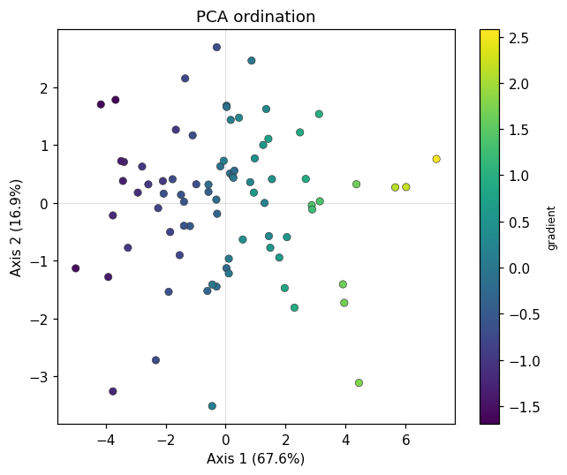
ordination scatter
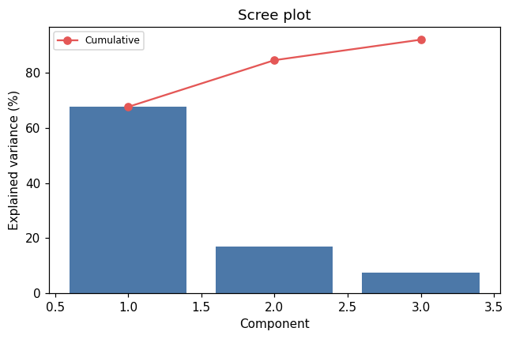
scree
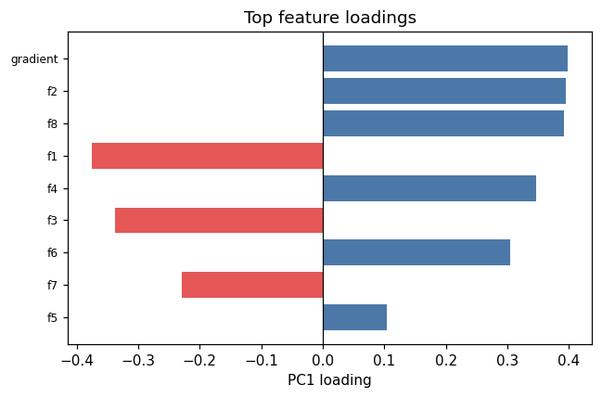
loadings

Method & Provenance
Metric | Value
method | Ordination — PCA
engine | Python · scikit-learn 1.8.0
datasets | gallery — example_ordination.csv
started | 2026-09-21 02:17:00.624418
permanent link | https://cat-g-omxpert.wishartlab.com/results/by-token/8a2cf4821c2941d4856886bb933d8044
Parameter | Value
ordination_method | pca
method | pca
feature_cols | gradient, f1, f2, f3, f4, f5, f6, f7, f8
n_components | 3
color_col | gradient

Command history
# python
from sklearn.decomposition import PCA
# python
from sklearn.preprocessing import StandardScaler
# python
X_scaled = StandardScaler().fit_transform(X)
# python
coords = PCA(n_components=3).fit_transform(X_scaled)

