Multiomics Result Result #87 — Analysis Report
Generated 2026-09-21 02:39:08 · 1 run(s) · CAT-G Data Analyzer

1. pca (#87)
2026-09-21 02:18:19 · multiomics_result · status: completed
The first two PCs capture 29.4% of the combined multi-omics variance.

explained variance
Component | Fraction | Cumulative
PC1 | 0.158399 | 0.158399
PC2 | 0.135564 | 0.293964
PC3 | 0.122593 | 0.416557
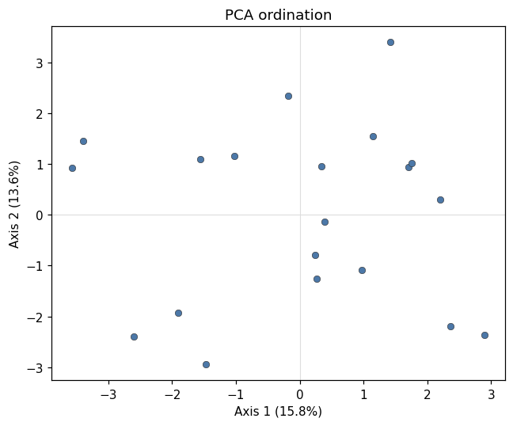
multiomics pca scatter
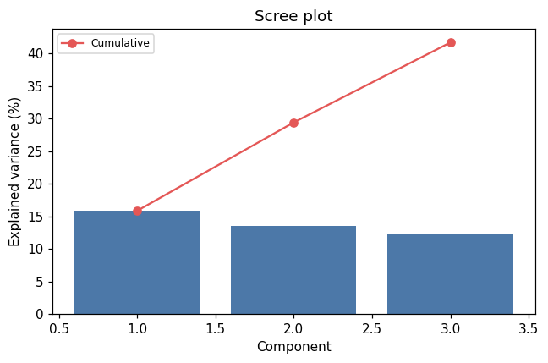
multiomics pca scree
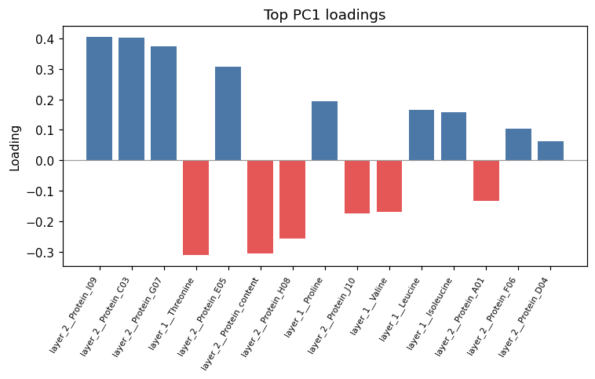
pca loadings bar

Method & Provenance
Metric | Value
method | Multi-omics — PCA
engine | Python · scikit-learn (PCA) 1.8.0
datasets | gallery — example_metabolomics.csv
started | 2026-09-21 02:18:19.384288
permanent link | https://cat-g-omxpert.wishartlab.com/multiomics/results/by-token/cf33b3a5a2614cd2b556dd9f7a646a10
Parameter | Value
dataset_ids | —
pipeline_type | pca

Command history
# python
from sklearn.decomposition import PCA
# python
coords = PCA(n_components=2).fit_transform(X)

