Multiomics Result Result #88 — Analysis Report
Generated 2026-09-21 02:39:12 · 1 run(s) · CAT-G Data Analyzer

1. cca (#88)
2026-09-21 02:18:24 · multiomics_result · status: completed
The first canonical variate correlates the two views at r = 1.000.

canonical correlations
Variate | Correlation
CV1 | 1.0
CV2 | 1.0
CV3 | 1.0

gallery — example metabolomics.csv top CV1 loadings
Feature | CV1 loading
Protein_content | -0.092203
Tryptophan | -0.004801
Valine | -0.004569
Serine | -0.004562
Leucine | -0.002716
Phenylalanine | 0.002147
Threonine | 0.001742
Isoleucine | -0.001573
Alanine | 0.001427
Proline | -0.001098
Glycine | -0.000278

gallery — example proteomics.csv top CV1 loadings
Feature | CV1 loading
Protein_content | -0.009469
Protein_E05 | 0.0
Protein_H08 | 0.0
Protein_F06 | -0.0
Protein_A01 | 0.0
Protein_D04 | 0.0
Protein_C03 | -0.0
Protein_I09 | -0.0
Protein_J10 | -0.0
Protein_G07 | 0.0
Protein_B02 | -0.0
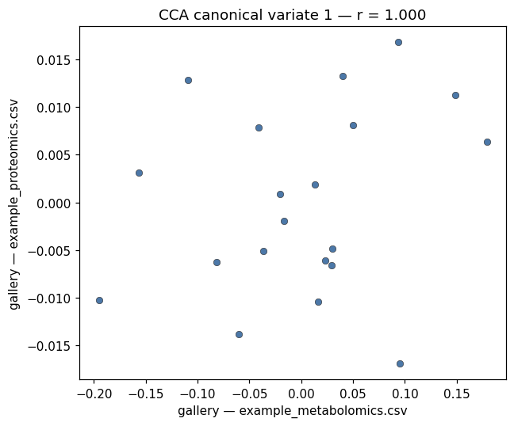
cca variate scatter
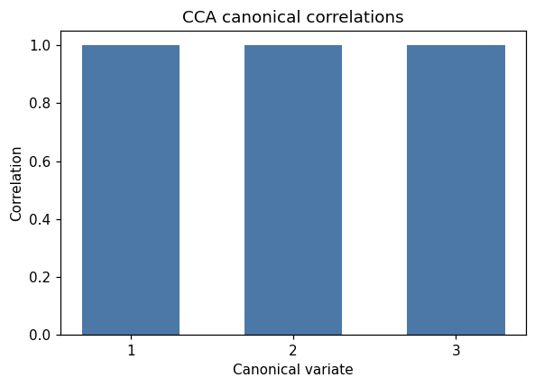
cca correlation bar
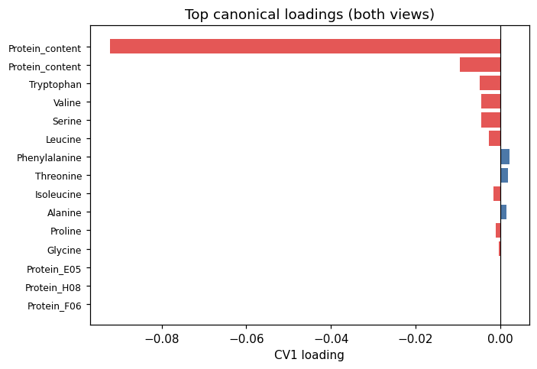
cca loadings bar

Warnings
- All canonical correlations are at or near 1.0. With 20 samples and 3 components the model is almost certainly overfit; interpret the correlations as a description of this dataset only, not as evidence of real cross-omics structure.

Method & Provenance
Metric | Value
method | Multi-omics — Canonical Correlation Analysis
engine | Python · statsmodels (CanCorr) 0.14.6
datasets | gallery — example_metabolomics.csv
started | 2026-09-21 02:18:24.618760
permanent link | https://cat-g-omxpert.wishartlab.com/multiomics/results/by-token/21244bc41b924556a8939806cdeb2457
Parameter | Value
dataset_ids | —
pipeline_type | cca

Command history
# python
from statsmodels.multivariate.cancorr import CanCorr
# python
cca = CanCorr(X_block, Y_block).fit()

