Statistical Test Result #188 — Analysis Report
Generated 2026-09-21 02:38:13 · 1 run(s) · CAT-G Data Analyzer

1. lmm (#188)
2026-09-21 02:16:46 · statistical_test · status: completed
The lmm on value completed.
Metric | Value
formula | value ~ C(treatment)
converged | True
n_obs | 120
n_groups | 40
loglikelihood | -218.983513
method | lmm
value_col | value
fixed_col | treatment
group_col | subject
significant | True

coefficients
term | coef | se | z | p | ci_lower | ci_upper
Intercept | 9.628778 | 0.463804 | 20.760446 | 0.0 | 8.719739 | 10.537817
C(treatment)[T.treated] | 3.54726 | 0.655918 | 5.408085 | 0.0 | 2.261684 | 4.832835
Group Var | 4.093659 | 1.233466 | 3.318825 | 0.000904 | 1.676109 | 6.511208
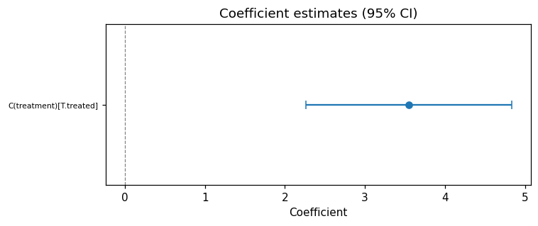
coef forest
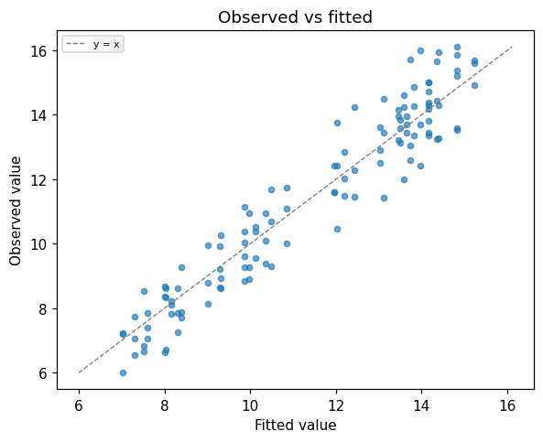
fitted vs observed
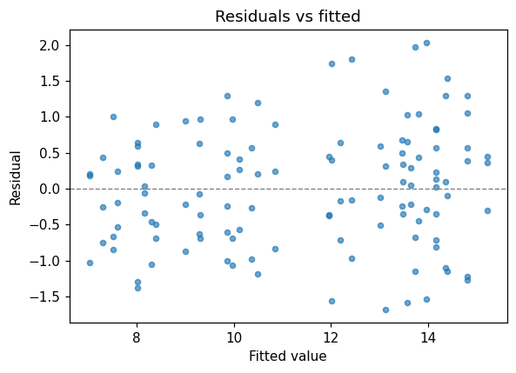
residuals vs fitted

Method & Provenance
Metric | Value
method | Linear mixed-effects model (random intercept)
engine | Python · statsmodels 0.14.6
datasets | gallery — example_lmm.csv
started | 2026-09-21 02:16:46.041991
permanent link | https://cat-g-omxpert.wishartlab.com/results/by-token/a59b0a0c337b4536a6b291f072aadf18
Parameter | Value
test_type | lmm
value_col | value
group_col | subject
fixed_col | treatment

Command history
# python
import statsmodels.formula.api as smf
# python
model = smf.mixedlm('value ~ fixed', data=df, groups=df['group_col'])
# python
fit = model.fit()

