Clustering Result #34 — Analysis Report
Generated 2026-09-21 02:38:39 · 1 run(s) · CAT-G Data Analyzer

1. agglomerative (#34)
2026-09-21 02:17:18 · clustering · status: completed
Clustering split 75 samples into 3 clusters (mean silhouette 0.479).
Metric | Value
method | agglomerative
k | 3
linkage | ward
silhouette | 0.479172
n_rows | 75
n_dropped | 0
derived_dataset_id | 714

sizes
name | value
0 | 25
1 | 25
2 | 25
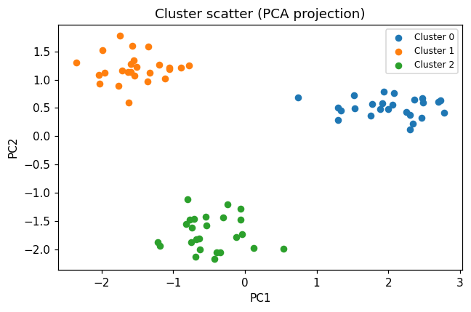
cluster scatter
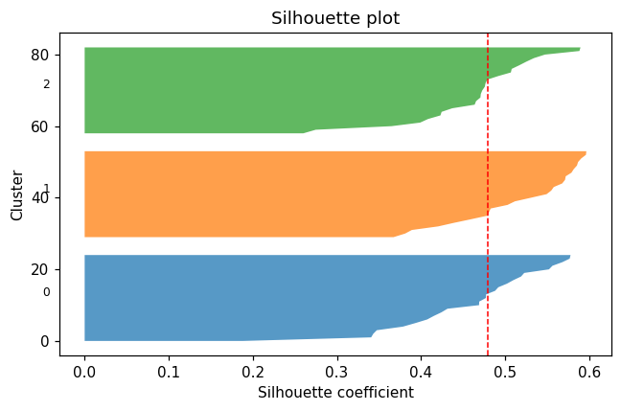
silhouette
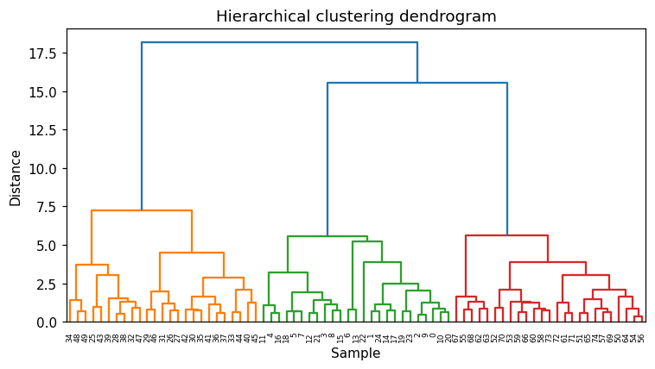
dendrogram

Method & Provenance
Metric | Value
method | Clustering — Agglomerative clustering
engine | Python · scikit-learn 1.8.0
datasets | gallery — example_clustering.csv
started | 2026-09-21 02:17:18.284433
permanent link | https://cat-g-omxpert.wishartlab.com/results/by-token/1a3dd8c3013a4c3bb4c0baa519c650e2
Parameter | Value
cluster_method | agglomerative
feature_cols | f1, f2, f3, f4, f5, f6
n_clusters | 3
linkage | ward

Command history
# python
from sklearn.cluster import AgglomerativeClustering
# python
labels = AgglomerativeClustering(n_clusters=3, linkage='ward').fit_predict(X)
# python
silhouette = sklearn.metrics.silhouette_score(X, labels)

