Clustering Result #33 — Analysis Report
Generated 2026-09-21 02:38:33 · 1 run(s) · CAT-G Data Analyzer

1. kmeans (#33)
2026-09-21 02:17:13 · clustering · status: completed
Clustering split 75 samples into 3 clusters (mean silhouette 0.479).
Metric | Value
method | kmeans
k | 3
silhouette | 0.479172
n_rows | 75
n_dropped | 0
derived_dataset_id | 713

sizes
name | value
0 | 25
1 | 25
2 | 25

inertia sweep
name | value
2 | 285.420962
3 | 164.583327
4 | 138.258257
5 | 122.455501
6 | 104.3279
7 | 92.095338
8 | 81.483783
9 | 73.163786
10 | 65.989041
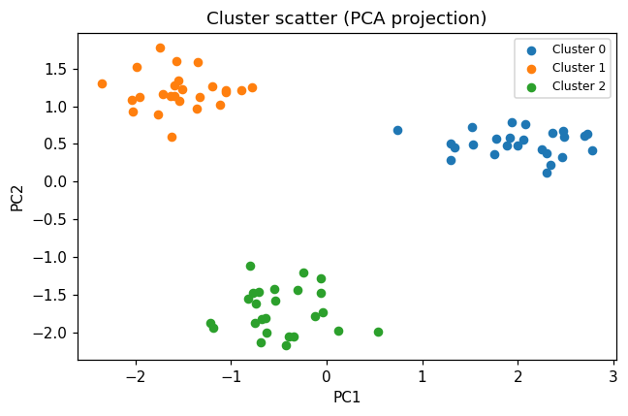
cluster scatter
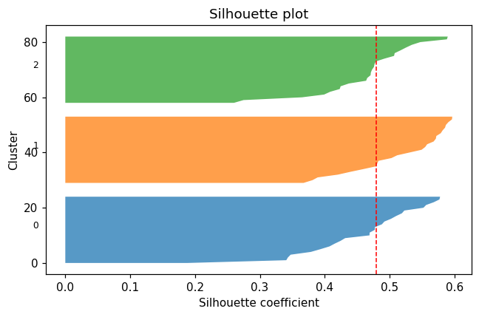
silhouette
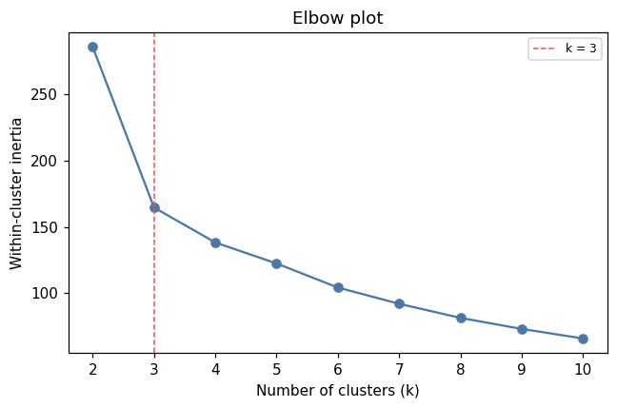
elbow

Method & Provenance
Metric | Value
method | Clustering — K-Means
engine | Python · scikit-learn 1.8.0
datasets | gallery — example_clustering.csv
started | 2026-09-21 02:17:13.556421
permanent link | https://cat-g-omxpert.wishartlab.com/results/by-token/952c914477ed424c80fc8abe48b2dd16
Parameter | Value
cluster_method | kmeans
feature_cols | f1, f2, f3, f4, f5, f6
n_clusters | 3

Command history
# python
from sklearn.cluster import KMeans
# python
labels = KMeans(n_clusters=3, n_init=10, random_state=42).fit_predict(X)
# python
silhouette = sklearn.metrics.silhouette_score(X, labels)

