Random Forest Result #149 — Analysis Report
Generated 2026-09-21 02:37:52 · 1 run(s) · CAT-G Data Analyzer

1. random forest (#149)
2026-09-21 02:16:12 · random_forest · status: completed
The model explains 0.0% of the variance in the target — worse than simply predicting the mean; treat predictions as unreliable.
Metric | Value
task_type | regression
r2_mean | -0.127684
r2_std | 0.430563
mse_mean | 3.420748
mse_std | 0.823789

permutation importance
name | mean | std
PLOT | 0.016337 | 0.003928
ENV_SOILNH4 | 0.004143 | 0.002695
ENV_SOILNO3 | 0.007993 | 0.006056
ENV_SOILP | 0.002755 | 0.00336
ENV_SOILOC | -0.005316 | 0.003437
ENV_SOILTN | -0.000658 | 0.003885
ENV_SOILTC | -0.005923 | 0.008819
ENV_PH | 0.00459 | 0.008166
ENV_SOILCLAY | 0.028921 | 0.009043
ENV_SOILSILT | -0.003407 | 0.006026

shap importance
name | mean_abs
PLOT | 0.070773
ENV_SOILNH4 | 0.019476
ENV_SOILNO3 | 0.028227
ENV_SOILP | 0.020736
ENV_SOILOC | 0.004994
ENV_SOILTN | 0.003569
ENV_SOILTC | 0.005338
ENV_PH | 0.026288
ENV_SOILCLAY | 0.100922
ENV_SOILSILT | 0.044507

split metrics
r2 | mse
-0.732183 | 3.698357
0.111214 | 4.261812
0.237916 | 2.302074
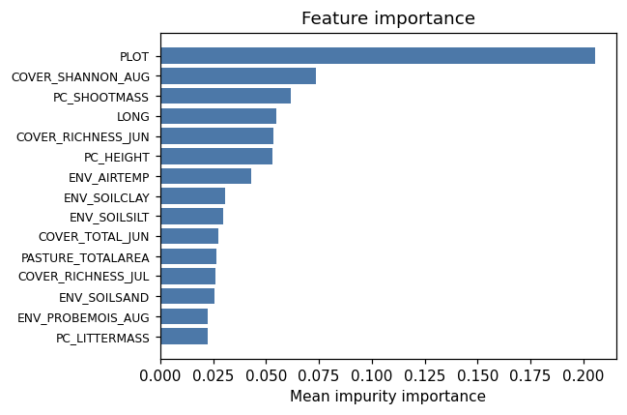
importance bar
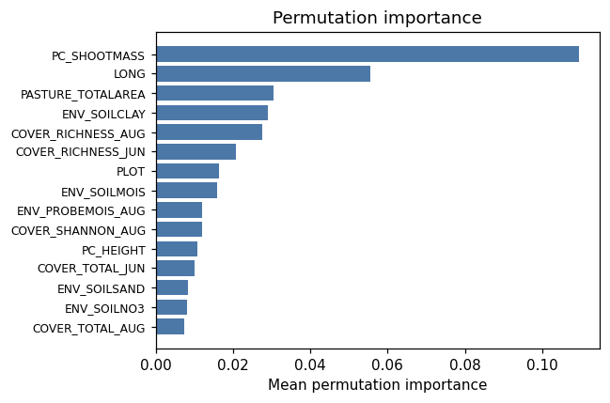
permutation bar
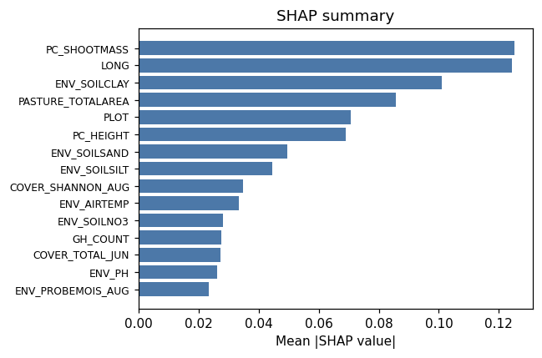
shap summary
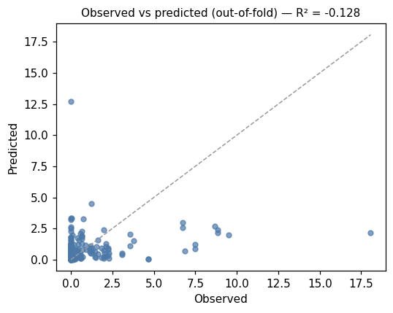
pred vs obs
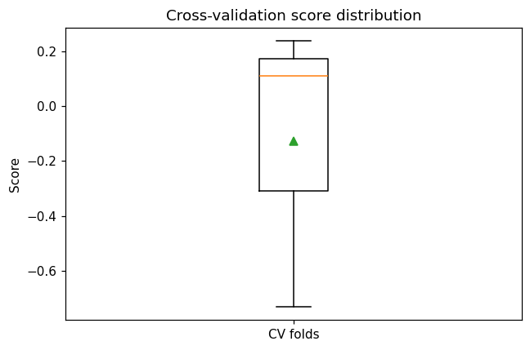
cv boxplot

Method & Provenance
Metric | Value
method | Random Forest (Regression)
engine | Python · scikit-learn 1.8.0
datasets | gallery — catg_example_08_woody_encroachment.csv
started | 2026-09-21 02:16:12.854253
permanent link | https://cat-g-omxpert.wishartlab.com/results/by-token/c2d3ecce80614f57be4dc0be42e7fcdb
Parameter | Value
task_type | regression
model_type | regression
target_column | PC_WOODMASS
n_estimators | 60
n_splits | 3
test_size | 0.25
run_univariate | True
run_permutation | True
run_shap | True
permutation_repeats | 10
fdr_threshold | 0.05

Command history
# python
from sklearn.ensemble import RandomForestRegressor
# python
model = RandomForestRegressor(n_estimators=60, random_state=42)
# python
scores = sklearn.model_selection.cross_val_score(model, X, y, cv=3)

