Random Forest Result #148 — Analysis Report
Generated 2026-09-21 02:37:42 · 1 run(s) · CAT-G Data Analyzer

1. random forest (#148)
2026-09-21 02:15:49 · random_forest · status: completed
The model explains 93.6% of the variance in the target under cross-validation.
Metric | Value
task_type | regression
r2_mean | 0.935626
r2_std | 0.055255
mse_mean | 32.913705
mse_std | 29.804256

permutation importance
name | mean | std
PLOT | 0.000829 | 0.001282
ENV_SOILNH4 | -0.003147 | 0.004054
ENV_SOILNO3 | 8.9e-05 | 0.000354
ENV_SOILP | -0.000501 | 0.000819
ENV_SOILOC | 2.4e-05 | 0.000269
ENV_SOILTN | 0.00232 | 0.002203
ENV_SOILTC | 0.000416 | 0.000181
ENV_PH | -0.000126 | 0.000154
ENV_SOILCLAY | 0.001992 | 0.000425
ENV_SOILSILT | 0.000718 | 0.001379

shap importance
name | mean_abs
PLOT | 0.195952
ENV_SOILNH4 | 0.10979
ENV_SOILNO3 | 0.064227
ENV_SOILP | 0.100928
ENV_SOILOC | 0.017297
ENV_SOILTN | 0.077718
ENV_SOILTC | 0.185985
ENV_PH | 0.02226
ENV_SOILCLAY | 0.558899
ENV_SOILSILT | 0.415885

split metrics
r2 | mse
0.990608 | 3.079392
0.860047 | 73.616049
0.956222 | 22.045674
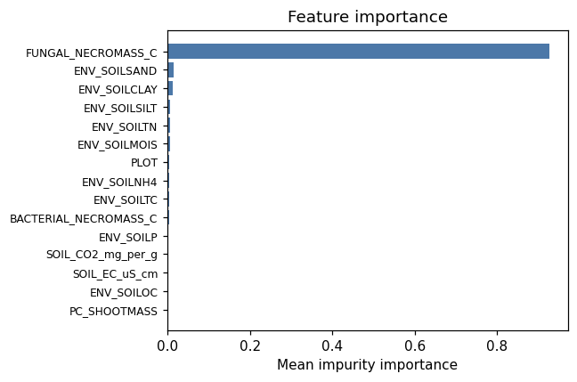
importance bar
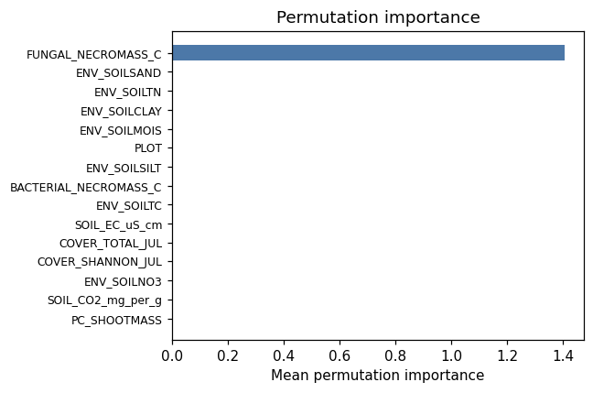
permutation bar
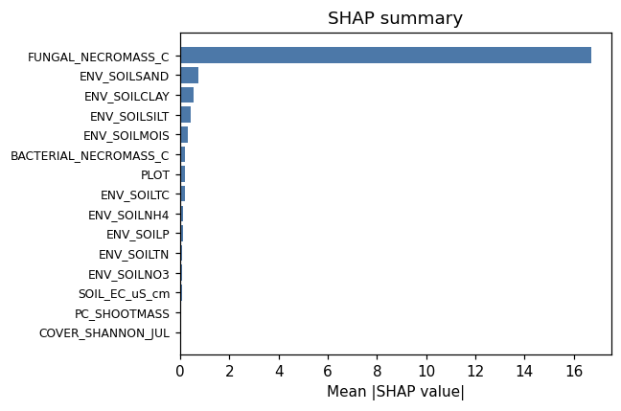
shap summary
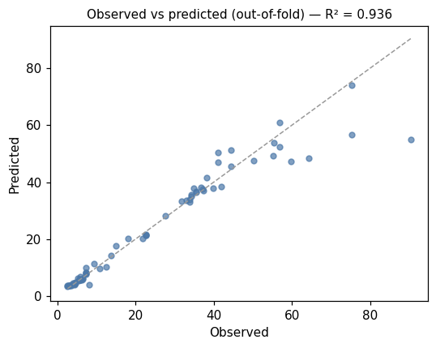
pred vs obs
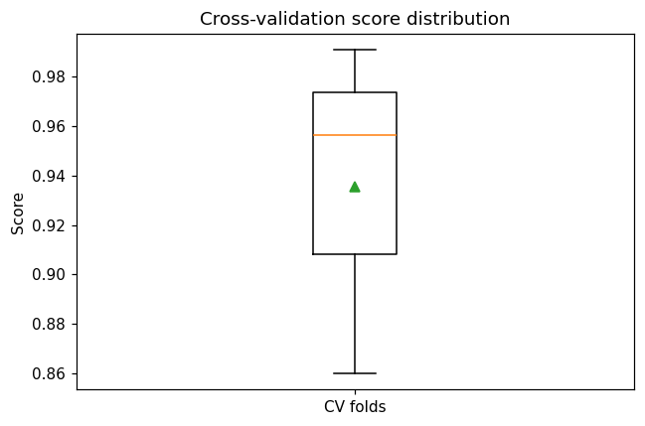
cv boxplot

Method & Provenance
Metric | Value
method | Random Forest (Regression)
engine | Python · scikit-learn 1.8.0
datasets | gallery — catg_example_07_microbial_soil_biology.csv
started | 2026-09-21 02:15:49.155216
permanent link | https://cat-g-omxpert.wishartlab.com/results/by-token/8705c62fa577496199d0d6e6fc4f47a1
Parameter | Value
task_type | regression
model_type | regression
target_column | MICROBIAL_NECROMASS_C
n_estimators | 60
n_splits | 3
test_size | 0.25
run_univariate | True
run_permutation | True
run_shap | True
permutation_repeats | 10
fdr_threshold | 0.05

Command history
# python
from sklearn.ensemble import RandomForestRegressor
# python
model = RandomForestRegressor(n_estimators=60, random_state=42)
# python
scores = sklearn.model_selection.cross_val_score(model, X, y, cv=3)

