Ordination Result #51 — Analysis Report
Generated 2026-09-21 02:37:46 · 1 run(s) · CAT-G Data Analyzer

1. ordination (#51)
2026-09-21 02:15:57 · ordination · status: completed
The first two PCA axes capture 50.3% of the total variance in the data.
Metric | Value
n_components | 3
method | pca
n_rows | 35
n_dropped | 61

explained variance
Axis | Fraction | Cumulative
Axis 1 | 0.350574 | 0.350574
Axis 2 | 0.151965 | 0.50254
Axis 3 | 0.109158 | 0.611697
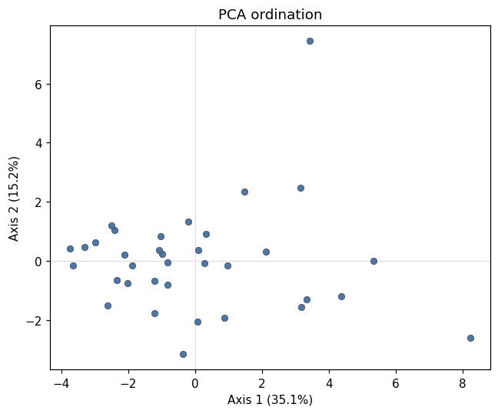
ordination scatter
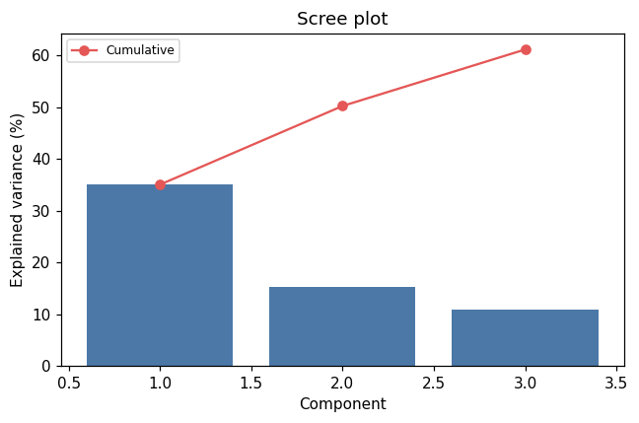
scree
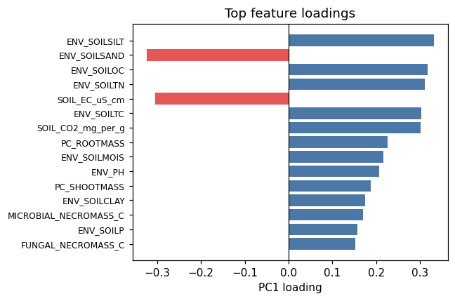
loadings

Warnings
- Excluded identifier-like numeric column(s): PLOT. These look like bookkeeping fields rather than measurements. Select feature columns explicitly if you intended to include them.

Method & Provenance
Metric | Value
method | Ordination — PCA
engine | Python · scikit-learn 1.8.0
datasets | gallery — catg_example_07_microbial_soil_biology.csv
started | 2026-09-21 02:15:57.280156
permanent link | https://cat-g-omxpert.wishartlab.com/results/by-token/fb6cf1f402b54feeabd9bf3da95b64e6
Parameter | Value
ordination_method | pca
method | pca
feature_cols | ENV_SOILNH4, ENV_SOILNO3, ENV_SOILP, ENV_SOILOC, ENV_SOILTN, ENV_SOILTC, ENV_PH, ENV_SOILCLAY, ENV_SOILSILT, ENV_SOILSAND, ENV_SOILMOIS, PC_SHOOTMASS, PC_ROOTMASS, PC_LITTERMASS, COVER_TOTAL_JUL, COVER_SHANNON_JUL, SOIL_EC_uS_cm, SOIL_CO2_mg_per_g, BACTERIAL_NECROMASS_C, FUNGAL_NECROMASS_C, MICROBIAL_NECROMASS_C
n_components | 3

Command history
# python
from sklearn.decomposition import PCA
# python
from sklearn.preprocessing import StandardScaler
# python
X_scaled = StandardScaler().fit_transform(X)
# python
coords = PCA(n_components=3).fit_transform(X_scaled)

