Random Forest Result #147 — Analysis Report
Generated 2026-09-21 02:37:29 · 1 run(s) · CAT-G Data Analyzer

1. random forest (#147)
2026-09-21 02:15:26 · random_forest · status: completed
The model explains 83.5% of the variance in the target under cross-validation.
Metric | Value
task_type | regression
r2_mean | 0.835335
r2_std | 0.043526
mse_mean | 0.76771
mse_std | 0.158907

permutation importance
name | mean | std
PLOT | 0.011739 | 0.018022
ENV_SOILNH4 | -0.00199 | 0.003367
ENV_SOILNO3 | 0.001999 | 0.000821
ENV_SOILP | -0.001752 | 0.001491
ENV_SOILTN | 0.064514 | 0.015946
ENV_SOILTC | 0.135219 | 0.012696
ENV_PH | 0.002762 | 0.000874
ENV_SOILCLAY | 0.001776 | 0.004232
ENV_SOILSILT | 0.073887 | 0.018645
ENV_SOILSAND | 0.022481 | 0.00901

shap importance
name | mean_abs
PLOT | 0.016825
ENV_SOILNH4 | 0.021395
ENV_SOILNO3 | 0.011124
ENV_SOILP | 0.00914
ENV_SOILTN | 0.70218
ENV_SOILTC | 0.727751
ENV_PH | 0.018506
ENV_SOILCLAY | 0.012148
ENV_SOILSILT | 0.113804
ENV_SOILSAND | 0.074886

split metrics
r2 | mse
0.867947 | 0.69667
0.864242 | 0.618589
0.773817 | 0.98787
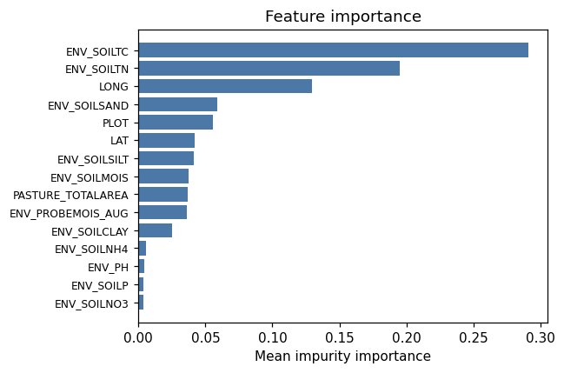
importance bar
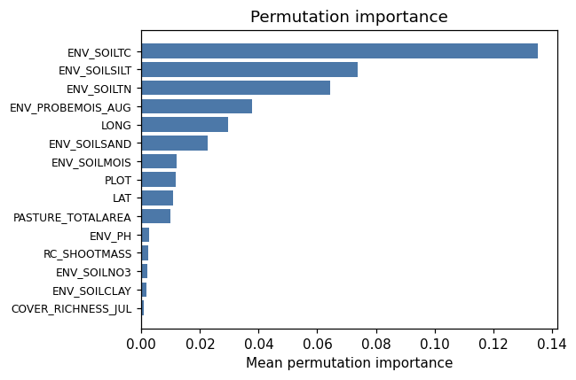
permutation bar
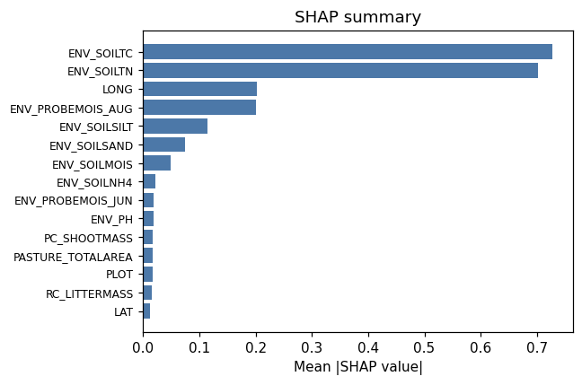
shap summary
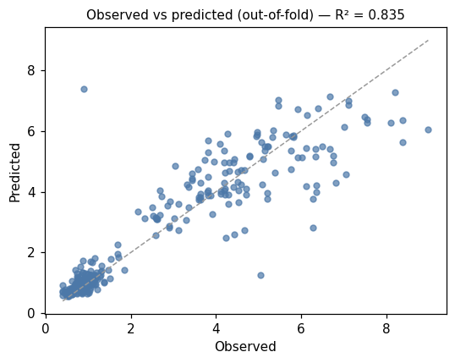
pred vs obs
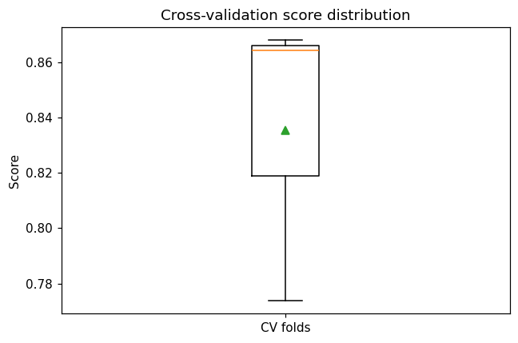
cv boxplot

Method & Provenance
Metric | Value
method | Random Forest (Regression)
engine | Python · scikit-learn 1.8.0
datasets | gallery — catg_example_06_soil_carbon_credits.csv
started | 2026-09-21 02:15:26.727584
permanent link | https://cat-g-omxpert.wishartlab.com/results/by-token/0af7a5128668442fb3b9c296168aaf7d
Parameter | Value
task_type | regression
model_type | regression
target_column | ENV_SOILOC
n_estimators | 60
n_splits | 3
test_size | 0.25
run_univariate | True
run_permutation | True
run_shap | True
permutation_repeats | 10
fdr_threshold | 0.05

Command history
# python
from sklearn.ensemble import RandomForestRegressor
# python
model = RandomForestRegressor(n_estimators=60, random_state=42)
# python
scores = sklearn.model_selection.cross_val_score(model, X, y, cv=3)

