Correlation Result #111 — Analysis Report
Generated 2026-09-21 02:37:36 · 1 run(s) · CAT-G Data Analyzer

1. correlation (#111)
2026-09-21 02:15:35 · correlation · status: completed
The strongest correlation is between LAT and LONG (r = 0.999, positive).
Metric | Value
n_pairs_tested | 496
n_significant_fdr_05 | 297
fdr_method | Benjamini-Hochberg
title | Correlation matrix
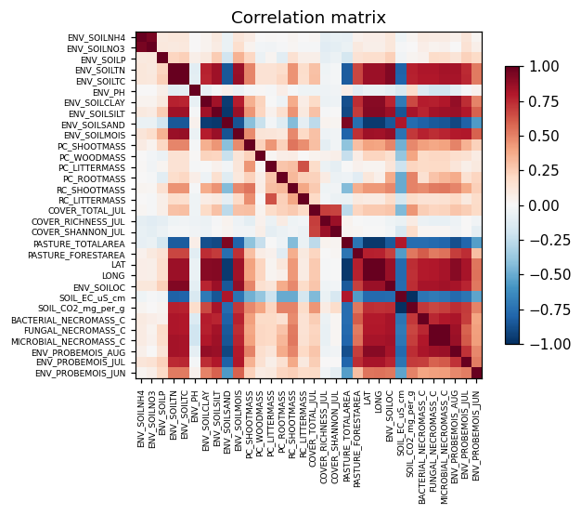
correlation heatmap
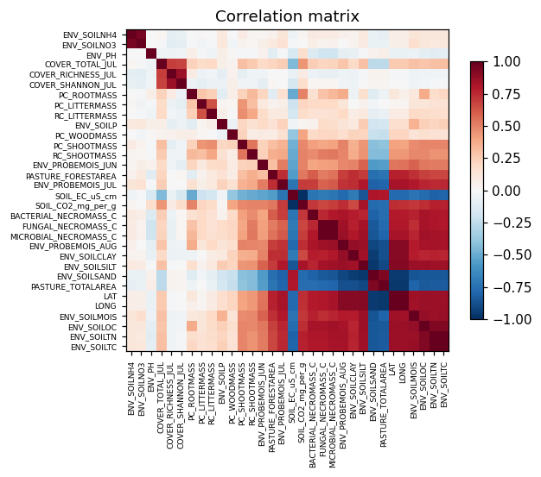
correlation clustered

Warnings
- Excluded identifier-like numeric column(s): PLOT. These look like bookkeeping fields rather than measurements and were left out of the correlation matrix.

Method & Provenance
Metric | Value
method | Pearson correlation
engine | Python · pandas/scipy 1.17.1
datasets | gallery — catg_example_06_soil_carbon_credits.csv
started | 2026-09-21 02:15:35.224408
permanent link | https://cat-g-omxpert.wishartlab.com/results/by-token/67a240894fb1422c9e923022c7c20417
Parameter | Value
method | pearson

Command history
# python
corr = df.corr(method='pearson')
# python
from scipy import stats
# python
r, p = stats.pearsonr(x, y) # per pair
# python
q = statsmodels.stats.multitest.multipletests(p_values, method='fdr_bh')

