Random Forest Result #146 — Analysis Report
Generated 2026-09-21 02:37:21 · 1 run(s) · CAT-G Data Analyzer

1. random forest (#146)
2026-09-21 02:15:02 · random_forest · status: completed
The model explains 77.2% of the variance in the target under cross-validation.
Metric | Value
task_type | regression
r2_mean | 0.77179
r2_std | 0.041005
mse_mean | 199.71057
mse_std | 27.668687

permutation importance
name | mean | std
PLOT | 0.000762 | 0.008948
ENV_SOILNH4 | -0.00042 | 0.002022
ENV_SOILNO3 | -0.000454 | 0.004077
ENV_SOILP | 0.004555 | 0.00288
ENV_SOILOC | 0.002502 | 0.004561
ENV_SOILTN | 0.016942 | 0.011589
ENV_SOILTC | 0.018122 | 0.00958
ENV_PH | -0.000352 | 0.000364
ENV_SOILCLAY | -0.000108 | 0.000876
ENV_SOILSILT | 0.005832 | 0.001824

shap importance
name | mean_abs
PLOT | 0.47108
ENV_SOILNH4 | 0.215687
ENV_SOILNO3 | 0.136184
ENV_SOILP | 0.350946
ENV_SOILOC | 0.854207
ENV_SOILTN | 0.358174
ENV_SOILTC | 0.571677
ENV_PH | 0.214236
ENV_SOILCLAY | 0.299414
ENV_SOILSILT | 0.290186

split metrics
r2 | mse
0.745856 | 234.197297
0.739838 | 198.477631
0.829675 | 166.456784
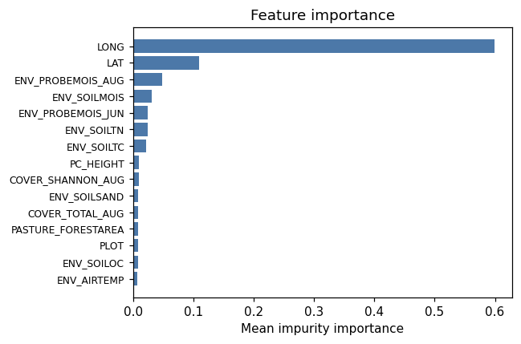
importance bar
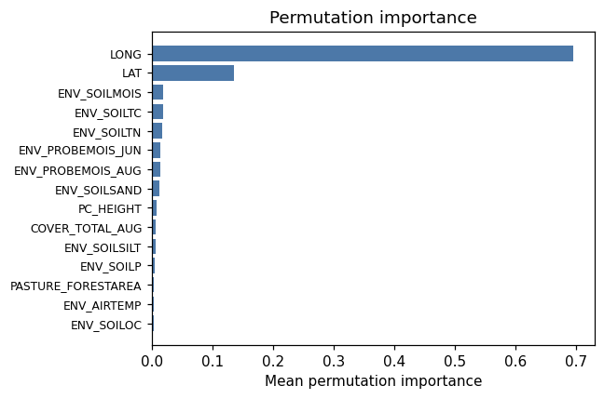
permutation bar
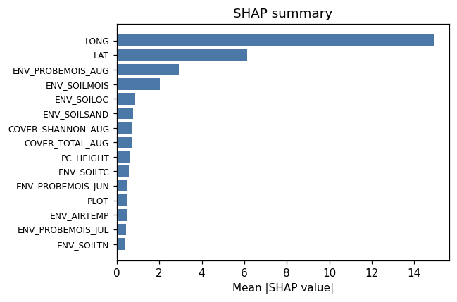
shap summary
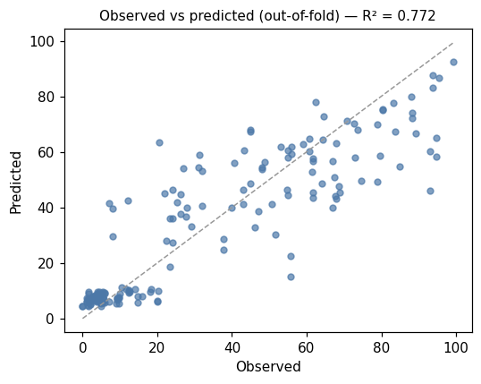
pred vs obs
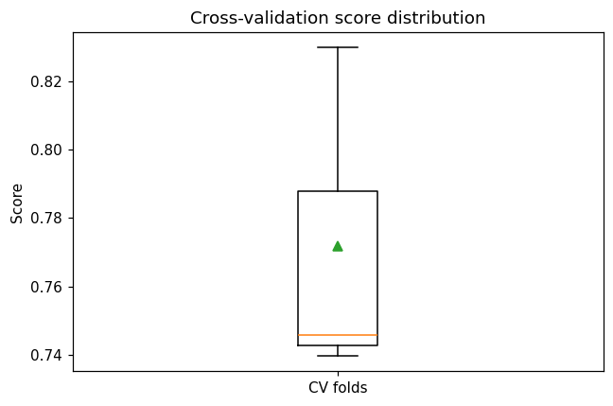
cv boxplot

Method & Provenance
Metric | Value
method | Random Forest (Regression)
engine | Python · scikit-learn 1.8.0
datasets | gallery — catg_example_05_grasshopper_pest_pressure.csv
started | 2026-09-21 02:15:02.446843
permanent link | https://cat-g-omxpert.wishartlab.com/results/by-token/41da97babc1945769dd1bb43f3a17845
Parameter | Value
task_type | regression
model_type | regression
target_column | GH_COUNT
n_estimators | 60
n_splits | 3
test_size | 0.25
run_univariate | True
run_permutation | True
run_shap | True
permutation_repeats | 10
fdr_threshold | 0.05

Command history
# python
from sklearn.ensemble import RandomForestRegressor
# python
model = RandomForestRegressor(n_estimators=60, random_state=42)
# python
scores = sklearn.model_selection.cross_val_score(model, X, y, cv=3)

