Statistical Test Result #182 — Analysis Report
Generated 2026-09-21 02:37:24 · 1 run(s) · CAT-G Data Analyzer

1. glm (#182)
2026-09-21 02:15:12 · statistical_test · status: completed
The glm on GH_COUNT completed.
Metric | Value
family | poisson
aic | 2948.86159
deviance | 1942.210341
null_deviance | 5619.785632
pseudo_r2 | 0.654398
n_obs | 207
dispersion_phi | 9.474405
deviance_gof_p | 0.0
method | glm
value_col | GH_COUNT
significant | True

coefficients
term | coef | se | z | p | ci_lower | ci_upper
const | 4.536949 | 0.019579 | 231.719669 | 0.0 | 4.498574 | 4.575324
ENV_SOILTN | -5.442332 | 0.119154 | -45.674756 | 0.0 | -5.675869 | -5.208794
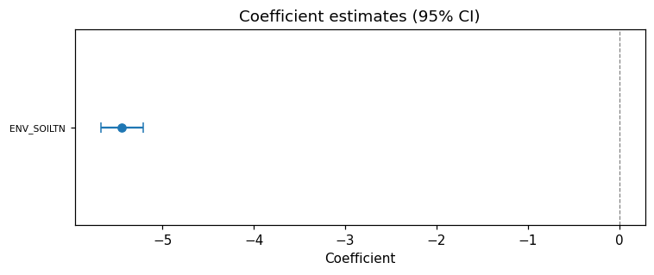
coef forest
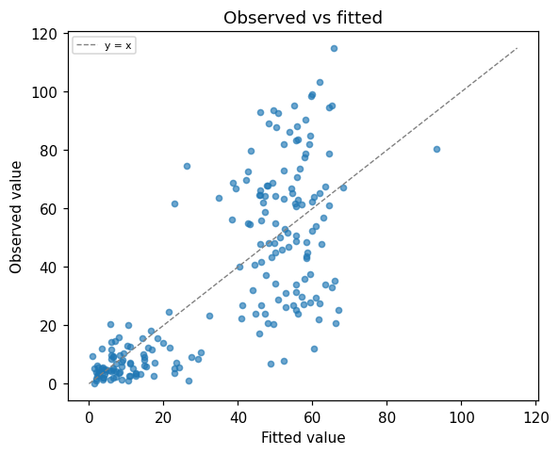
fitted vs observed
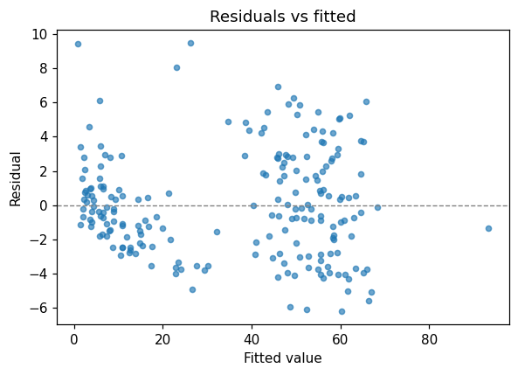
residuals vs fitted

Warnings
- The data appear overdispersed relative to the Poisson model (Pearson phi = 9.47; values near 1 are expected). Coefficient standard errors are likely too small — refit with the Negative Binomial family.
- The deviance goodness-of-fit test rejects adequate fit (p = 3.402e-280); residual structure may remain unexplained.

Method & Provenance
Metric | Value
method | Count GLM (Poisson / Negative Binomial)
engine | Python · statsmodels 0.14.6
datasets | gallery — catg_example_05_grasshopper_pest_pressure.csv
started | 2026-09-21 02:15:12.174965
permanent link | https://cat-g-omxpert.wishartlab.com/results/by-token/e5dac942c0614cd5bc9baa1859614534
Parameter | Value
test_type | glm
value_col | GH_COUNT
predictor_cols | ENV_SOILTN

Command history
# python
import statsmodels.api as sm
# python
model = sm.GLM(y_counts, X_predictors, family=sm.families.Poisson())
# python
fit = model.fit()

