Random Forest Result #145 — Analysis Report
Generated 2026-09-21 02:37:13 · 1 run(s) · CAT-G Data Analyzer

1. random forest (#145)
2026-09-21 02:14:42 · random_forest · status: completed
The model explains 78.4% of the variance in the target under cross-validation.
Metric | Value
task_type | regression
r2_mean | 0.784445
r2_std | 0.027108
mse_mean | 0.028559
mse_std | 0.001398

permutation importance
name | mean | std
PLOT | 0.001728 | 0.001922
ENV_SOILNH4 | 0.001038 | 0.001454
ENV_SOILNO3 | -0.000827 | 0.001448
ENV_SOILP | -0.001439 | 0.001833
ENV_SOILOC | 0.002019 | 0.000753
ENV_SOILTN | -0.000309 | 0.000756
ENV_SOILTC | -0.000263 | 0.001078
ENV_PH | 0.001013 | 0.000999
ENV_SOILCLAY | -0.001452 | 0.00374
ENV_SOILSILT | 1.2e-05 | 0.001276

shap importance
name | mean_abs
PLOT | 0.002544
ENV_SOILNH4 | 0.001869
ENV_SOILNO3 | 0.002629
ENV_SOILP | 0.002738
ENV_SOILOC | 0.002754
ENV_SOILTN | 0.001206
ENV_SOILTC | 0.001763
ENV_PH | 0.006021
ENV_SOILCLAY | 0.002991
ENV_SOILSILT | 0.002607

split metrics
r2 | mse
0.746124 | 0.030228
0.80457 | 0.026807
0.802639 | 0.028641
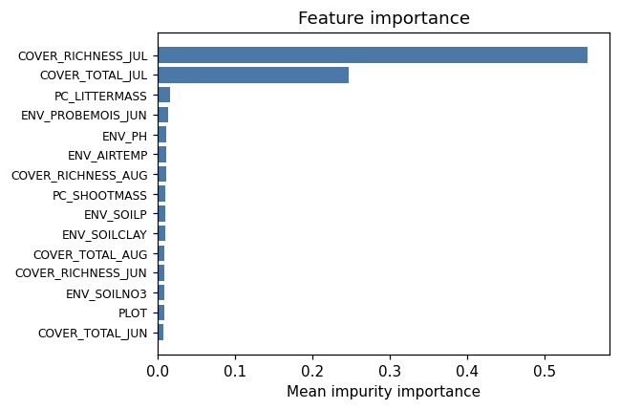
importance bar
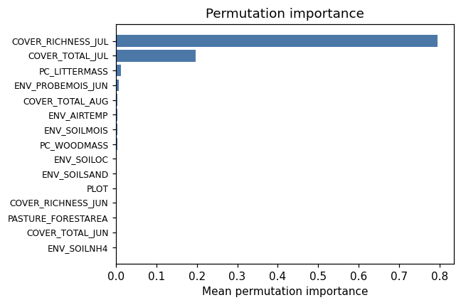
permutation bar
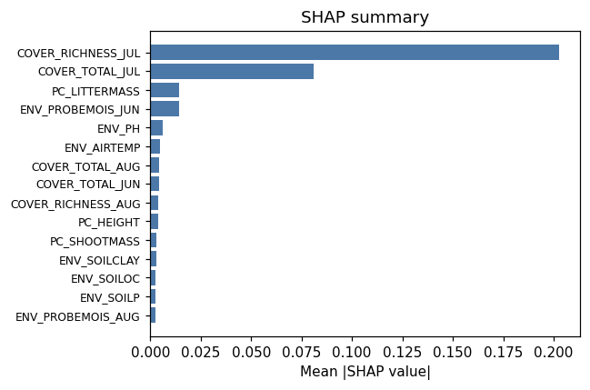
shap summary
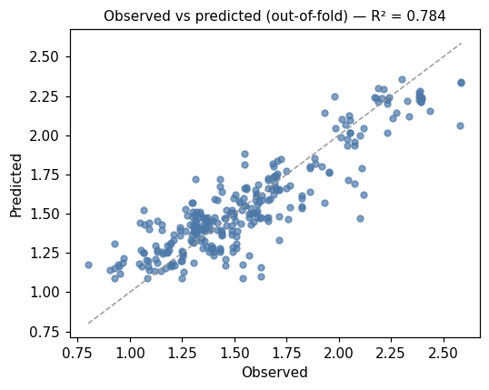
pred vs obs
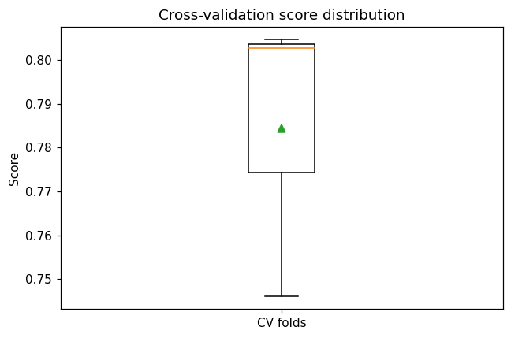
cv boxplot

Method & Provenance
Metric | Value
method | Random Forest (Regression)
engine | Python · scikit-learn 1.8.0
datasets | gallery — catg_example_04_vegetation_diversity.csv
started | 2026-09-21 02:14:42.722532
permanent link | https://cat-g-omxpert.wishartlab.com/results/by-token/023c0e89aaf94a488763f77c20de38a3
Parameter | Value
task_type | regression
model_type | regression
target_column | COVER_SHANNON_JUL
n_estimators | 60
n_splits | 3
test_size | 0.25
run_univariate | True
run_permutation | True
run_shap | True
permutation_repeats | 10
fdr_threshold | 0.05

Command history
# python
from sklearn.ensemble import RandomForestRegressor
# python
model = RandomForestRegressor(n_estimators=60, random_state=42)
# python
scores = sklearn.model_selection.cross_val_score(model, X, y, cv=3)

