Random Forest Result #144 — Analysis Report
Generated 2026-09-21 02:36:58 · 1 run(s) · CAT-G Data Analyzer

1. random forest (#144)
2026-09-21 02:14:14 · random_forest · status: completed
The model explains 53.9% of the variance in the target under cross-validation.
Metric | Value
task_type | regression
r2_mean | 0.538756
r2_std | 0.214189
mse_mean | 14.986814
mse_std | 12.519635

permutation importance
name | mean | std
PLOT | 0.011272 | 0.008572
ENV_SOILOC | 0.001235 | 0.007825
ENV_SOILTC | 0.002577 | 0.011296
ENV_SOILTN | 0.102671 | 0.070685
ENV_PH | -0.002838 | 0.002858
ENV_SOILCLAY | 0.01445 | 0.009704
ENV_SOILSILT | 0.006406 | 0.023445
ENV_SOILSAND | 0.010353 | 0.00754
ENV_SOILMOIS | 0.021319 | 0.018914
ENV_SOILP | 0.000114 | 0.000991

shap importance
name | mean_abs
PLOT | 0.1131
ENV_SOILOC | 0.183659
ENV_SOILTC | 0.126229
ENV_SOILTN | 0.327007
ENV_PH | 0.109797
ENV_SOILCLAY | 0.061339
ENV_SOILSILT | 0.167248
ENV_SOILSAND | 0.065622
ENV_SOILMOIS | 0.205682
ENV_SOILP | 0.03121

split metrics
r2 | mse
0.308397 | 5.958141
0.483595 | 6.311223
0.824277 | 32.691079
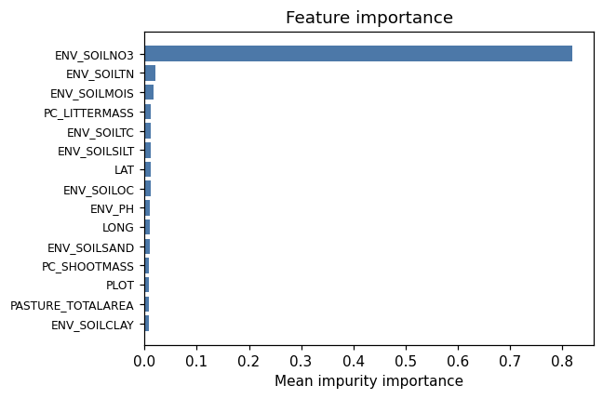
importance bar
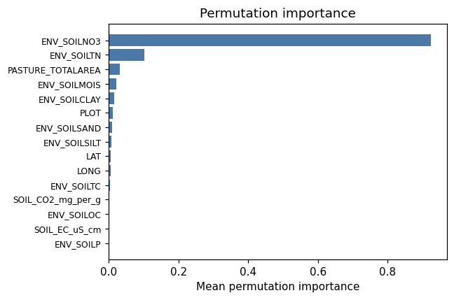
permutation bar
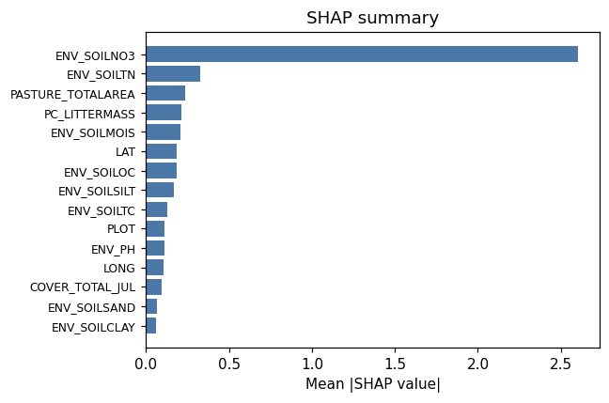
shap summary
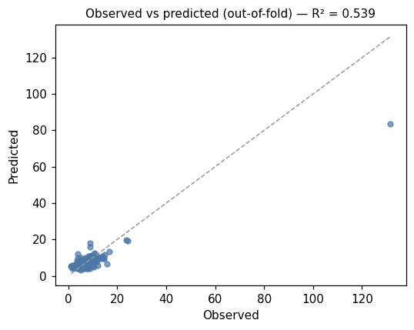
pred vs obs
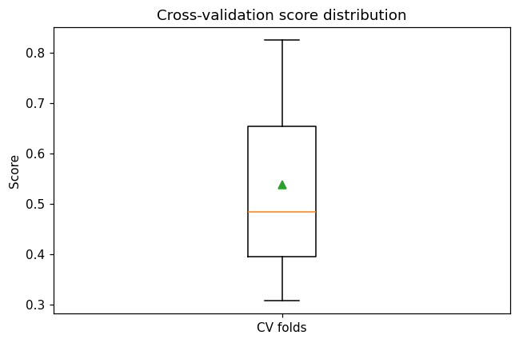
cv boxplot

Method & Provenance
Metric | Value
method | Random Forest (Regression)
engine | Python · scikit-learn 1.8.0
datasets | gallery — catg_example_03_soil_nitrogen_availability.csv
started | 2026-09-21 02:14:14.068246
permanent link | https://cat-g-omxpert.wishartlab.com/results/by-token/413ee895cd9742ed95bd1502567c309a
Parameter | Value
task_type | regression
model_type | regression
target_column | ENV_SOILNH4
n_estimators | 60
n_splits | 3
test_size | 0.25
run_univariate | True
run_permutation | True
run_shap | True
permutation_repeats | 10
fdr_threshold | 0.05

Command history
# python
from sklearn.ensemble import RandomForestRegressor
# python
model = RandomForestRegressor(n_estimators=60, random_state=42)
# python
scores = sklearn.model_selection.cross_val_score(model, X, y, cv=3)

