Random Forest Result #143 — Analysis Report
Generated 2026-09-21 02:36:47 · 1 run(s) · CAT-G Data Analyzer

1. random forest (#143)
2026-09-21 02:13:52 · random_forest · status: completed
The model explains 0.0% of the variance in the target — worse than simply predicting the mean; treat predictions as unreliable.
Metric | Value
task_type | regression
r2_mean | -0.049195
r2_std | 0.029871
mse_mean | 7.227791
mse_std | 0.20578

permutation importance
name | mean | std
MEAN_PC_SHOOTMASS | 0.084806 | 0.005584
MEAN_RC_SHOOTMASS | 0.130502 | 0.104911
MEAN_PC_HEIGHT | 0.026103 | 0.019747
MEAN_ENV_SOILOC | 0.198789 | 0.075698
MEAN_ENV_SOILMOIS | 0.088199 | 0.114618
MEAN_ENV_SOILTN | 0.328192 | 0.01486
MEAN_COVER_TOTAL_JUL | 0.132638 | 0.067458
MEAN_COVER_SHANNON_JUL | -0.027903 | 0.031621
MEAN_PC_WOODMASS | -0.056028 | 0.025228
PLOT_COUNT | -0.048951 | 0.055505

shap importance
name | mean_abs
MEAN_PC_SHOOTMASS | 0.265275
MEAN_RC_SHOOTMASS | 0.305043
MEAN_PC_HEIGHT | 0.112237
MEAN_ENV_SOILOC | 0.108948
MEAN_ENV_SOILMOIS | 0.225008
MEAN_ENV_SOILTN | 0.342947
MEAN_COVER_TOTAL_JUL | 0.173261
MEAN_COVER_SHANNON_JUL | 0.085411
MEAN_PC_WOODMASS | 0.228746
PLOT_COUNT | 0.009979

split metrics
r2 | mse
-0.079067 | 7.43357
-0.019324 | 7.022011
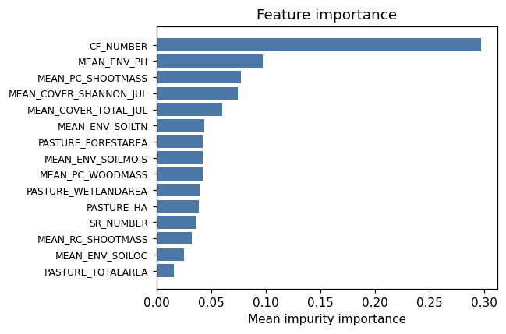
importance bar
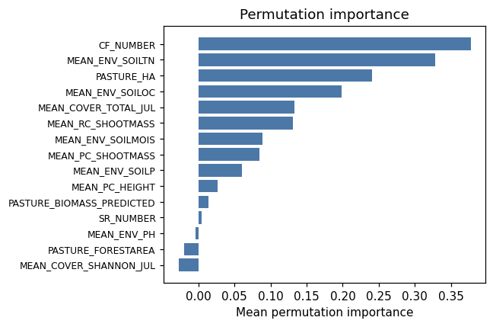
permutation bar
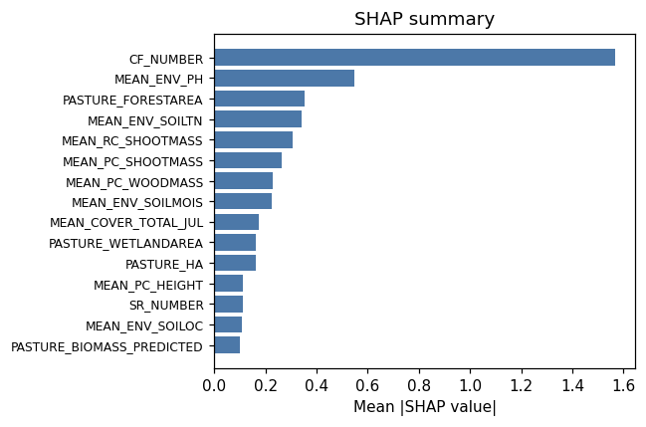
shap summary
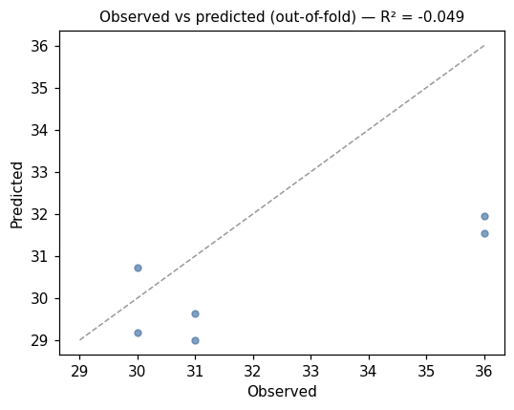
pred vs obs
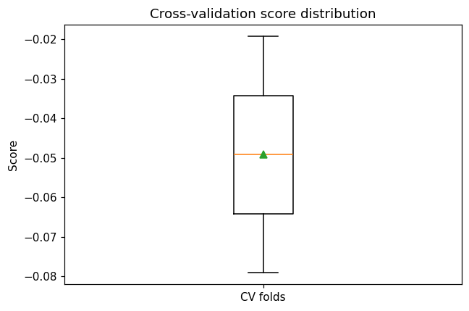
cv boxplot

Method & Provenance
Metric | Value
method | Random Forest (Regression)
engine | Python · scikit-learn 1.8.0
datasets | gallery — catg_example_02_grazing_carrying_capacity.csv
started | 2026-09-21 02:13:52.593069
permanent link | https://cat-g-omxpert.wishartlab.com/results/by-token/c2f085d2764a43e3b8a578284d15edb5
Parameter | Value
task_type | regression
model_type | regression
target_column | CW_NUMBER
n_estimators | 60
n_splits | 2
test_size | 0.25
run_univariate | True
run_permutation | True
run_shap | True
permutation_repeats | 10
fdr_threshold | 0.05

Command history
# python
from sklearn.ensemble import RandomForestRegressor
# python
model = RandomForestRegressor(n_estimators=60, random_state=42)
# python
scores = sklearn.model_selection.cross_val_score(model, X, y, cv=2)

