Correlation Result #109 — Analysis Report
Generated 2026-09-21 02:36:52 · 1 run(s) · CAT-G Data Analyzer

1. correlation (#109)
2026-09-21 02:14:01 · correlation · status: completed
The strongest correlation is between MEAN_ENV_SOILOC and MEAN_ENV_SOILTN (r = 0.996, positive).
Metric | Value
n_pairs_tested | 190
n_significant_fdr_05 | 58
fdr_method | Benjamini-Hochberg
title | Correlation matrix
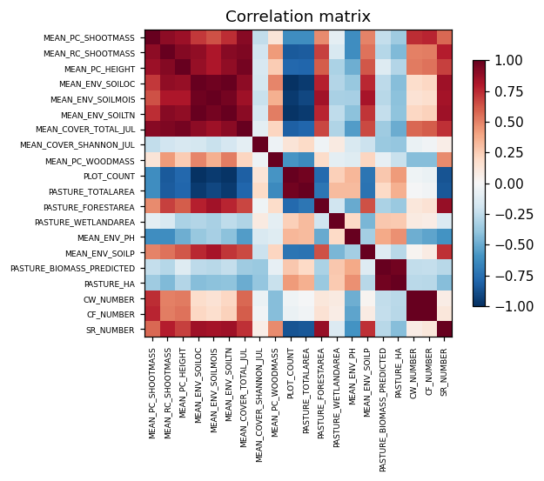
correlation heatmap
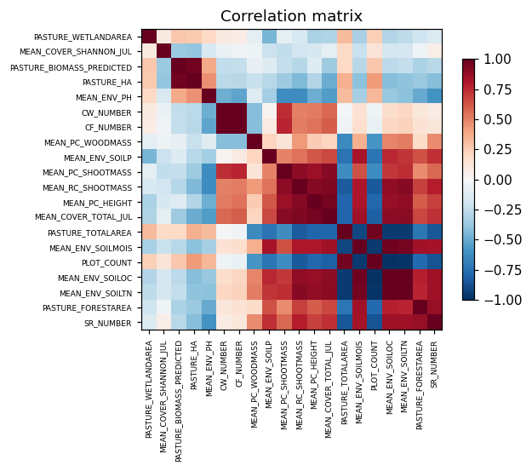
correlation clustered

Method & Provenance
Metric | Value
method | Pearson correlation
engine | Python · pandas/scipy 1.17.1
datasets | gallery — catg_example_02_grazing_carrying_capacity.csv
started | 2026-09-21 02:14:01.070211
permanent link | https://cat-g-omxpert.wishartlab.com/results/by-token/7dd486646cea49a78f4f0059dde2e974
Parameter | Value
method | pearson

Command history
# python
corr = df.corr(method='pearson')
# python
from scipy import stats
# python
r, p = stats.pearsonr(x, y) # per pair
# python
q = statsmodels.stats.multitest.multipletests(p_values, method='fdr_bh')

