Random Forest Result #141 — Analysis Report
Generated 2026-09-21 02:36:32 · 1 run(s) · CAT-G Data Analyzer

1. random forest (#141)
2026-09-21 02:13:18 · random_forest · status: completed
The model explains 35.0% of the variance in the target under cross-validation.
Metric | Value
task_type | regression
r2_mean | 0.349724
r2_std | 0.151744
mse_mean | 50.844263
mse_std | 2.643804

permutation importance
name | mean | std
PLOT | 0.009137 | 0.004065
ENV_SOILNH4 | -2.9e-05 | 0.006682
ENV_SOILNO3 | 0.002389 | 0.000391
ENV_SOILP | -0.001287 | 0.019213
ENV_SOILOC | -0.002492 | 0.006131
ENV_SOILTN | -0.001218 | 0.002395
ENV_SOILTC | -0.004529 | 0.012192
ENV_PH | -0.00026 | 0.000269
ENV_SOILCLAY | 0.000249 | 0.00296
ENV_SOILSILT | -0.014357 | 0.015714

shap importance
name | mean_abs
PLOT | 0.120615
ENV_SOILNH4 | 0.082636
ENV_SOILNO3 | 0.088722
ENV_SOILP | 0.259756
ENV_SOILOC | 0.12071
ENV_SOILTN | 0.23526
ENV_SOILTC | 0.273367
ENV_PH | 0.138988
ENV_SOILCLAY | 0.057941
ENV_SOILSILT | 0.203845

split metrics
r2 | mse
0.541696 | 54.270766
0.336802 | 47.835304
0.170674 | 50.426719
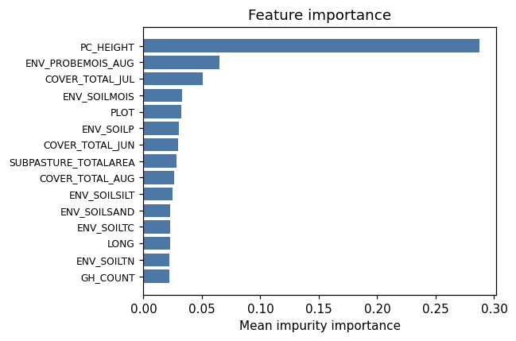
importance bar
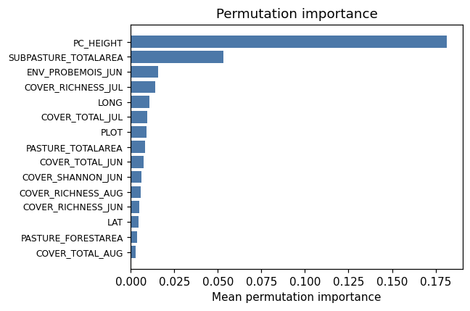
permutation bar
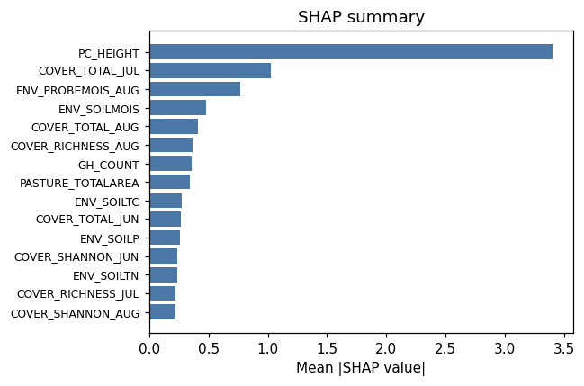
shap summary
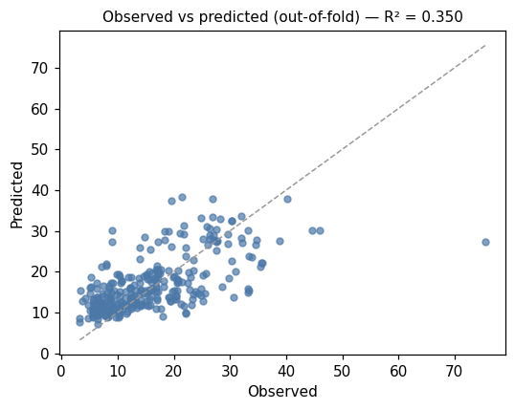
pred vs obs
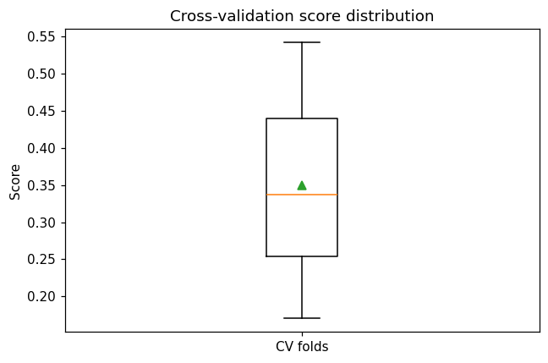
cv boxplot

Method & Provenance
Metric | Value
method | Random Forest (Regression)
engine | Python · scikit-learn 1.8.0
datasets | gallery — catg_example_01_forage_biomass.csv (preprocessed)
started | 2026-09-21 02:13:18.142034
permanent link | https://cat-g-omxpert.wishartlab.com/results/by-token/f95ceea32876467a84d79698d140674d
Parameter | Value
task_type | regression
model_type | regression
target_column | PC_SHOOTMASS
n_estimators | 60
n_splits | 3
test_size | 0.25
run_univariate | True
run_permutation | True
run_shap | True
permutation_repeats | 10
fdr_threshold | 0.05

Command history
# python
from sklearn.ensemble import RandomForestRegressor
# python
model = RandomForestRegressor(n_estimators=60, random_state=42)
# python
scores = sklearn.model_selection.cross_val_score(model, X, y, cv=3)

