Random Forest Result #142 — Analysis Report
Generated 2026-09-21 02:36:39 · 1 run(s) · CAT-G Data Analyzer

1. random forest (#142)
2026-09-21 02:13:38 · random_forest · status: completed
The model explains 34.6% of the variance in the target under cross-validation.
Metric | Value
task_type | regression
r2_mean | 0.345639
r2_std | 0.122952
mse_mean | 52.232806
mse_std | 7.541088

permutation importance
name | mean | std
PLOT | 0.021128 | 0.013875
ENV_SOILNH4 | 0.001802 | 0.001265
ENV_SOILNO3 | 0.003362 | 0.003329
ENV_SOILP | 0.016495 | 0.003534
ENV_SOILOC | 0.009076 | 0.016
ENV_SOILTN | 0.009067 | 0.012805
ENV_SOILTC | 0.014288 | 0.047237
ENV_PH | 0.001249 | 0.002939
ENV_SOILCLAY | 0.003314 | 0.004583
ENV_SOILSILT | -0.00579 | 0.007295

shap importance
name | mean_abs
PLOT | 0.247639
ENV_SOILNH4 | 0.103296
ENV_SOILNO3 | 0.094585
ENV_SOILP | 0.217172
ENV_SOILOC | 0.29234
ENV_SOILTN | 0.782153
ENV_SOILTC | 0.765265
ENV_PH | 0.156054
ENV_SOILCLAY | 0.06528
ENV_SOILSILT | 0.188871

split metrics
r2 | mse
0.472938 | 62.41285
0.384566 | 44.390142
0.179412 | 49.895425
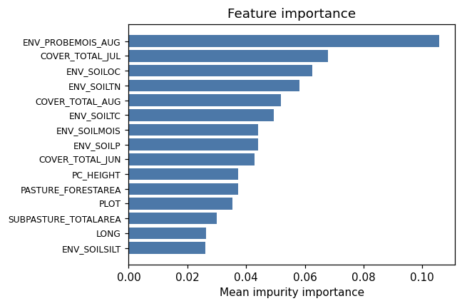
importance bar
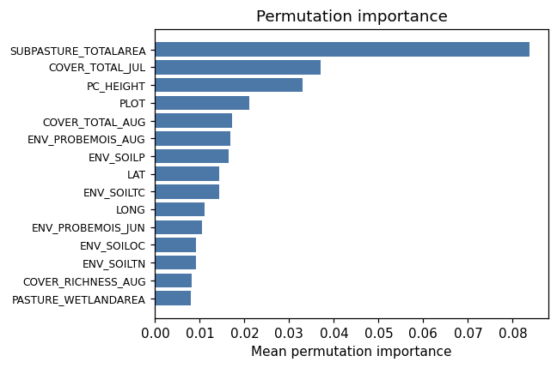
permutation bar
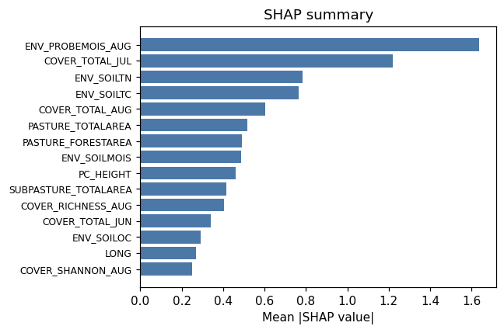
shap summary
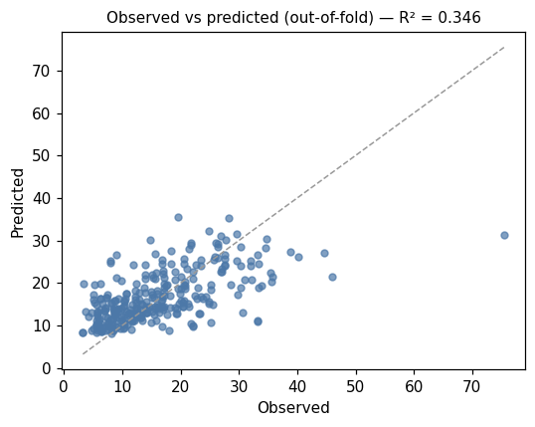
pred vs obs
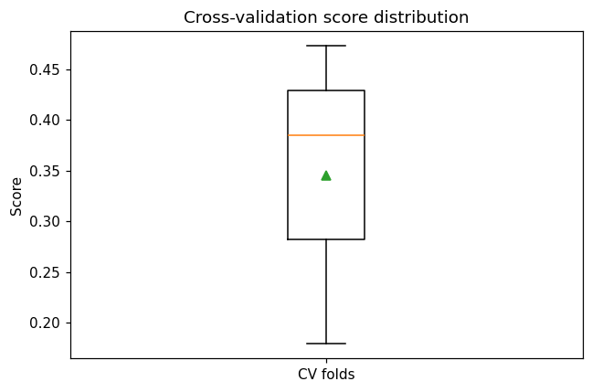
cv boxplot

Method & Provenance
Metric | Value
method | Random Forest (Regression)
engine | Python · scikit-learn 1.8.0
datasets | gallery — catg_example_01_forage_biomass.csv
started | 2026-09-21 02:13:38.003816
permanent link | https://cat-g-omxpert.wishartlab.com/results/by-token/96b7753d8e314763a196bb620423f685
Parameter | Value
task_type | regression
model_type | regression
target_column | PC_SHOOTMASS
n_estimators | 60
n_splits | 3
test_size | 0.25
run_univariate | True
run_permutation | True
run_shap | True
permutation_repeats | 10
fdr_threshold | 0.05

Command history
# python
from sklearn.ensemble import RandomForestRegressor
# python
model = RandomForestRegressor(n_estimators=60, random_state=42)
# python
scores = sklearn.model_selection.cross_val_score(model, X, y, cv=3)

