Preprocessing Result #35 — Analysis Report
Generated 2026-09-21 02:36:26 · 1 run(s) · CAT-G Data Analyzer

1. preprocessing (#35)
2026-09-21 02:12:55 · preprocessing · status: completed
Preprocessing transformed the dataset from 393 rows to 393 rows with 33 output features.
Metric | Value
n_rows_in | 393
n_rows_out | 393
n_features_out | 33
target_col | PC_SHOOTMASS
derived_dataset_id | 695

outlier report
name | value
method | iqr
handling | flag
n_outliers_detected | 17
n_original | 393
min_cols_required | 4
n_removed | 0
timing | before_split
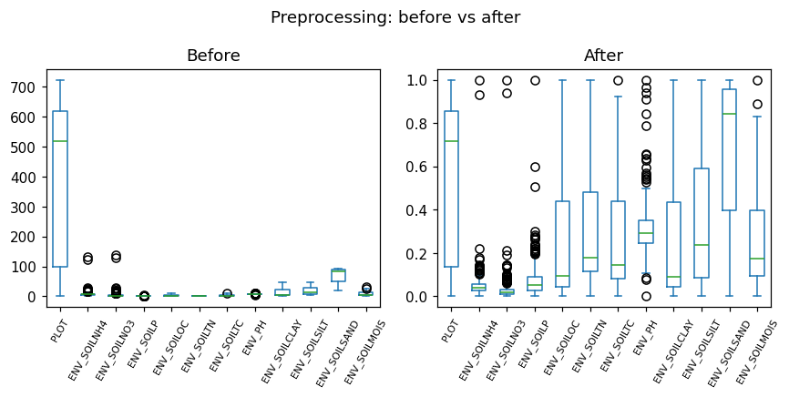
before after boxplot
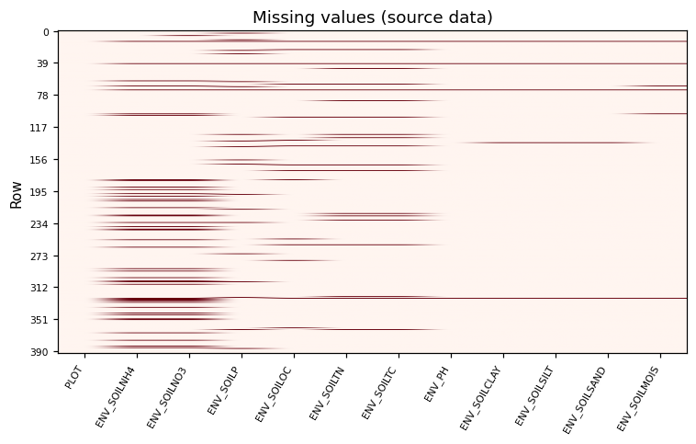
missingness heatmap

Method & Provenance
Metric | Value
method | Preprocessing
engine | Python · pandas/scikit-learn 3.0.3
datasets | gallery — catg_example_01_forage_biomass.csv
started | 2026-09-21 02:12:55.894015
permanent link | https://cat-g-omxpert.wishartlab.com/results/by-token/3496fe33b6fd47cc9409f0c0d5edb0d3
Parameter | Value
normalization | {'method': 'min-max'}
outlier_handling | {'method': 'iqr', 'handling': 'flag', 'min_col_fraction': 0.1}
steps | missing_value_imputation → normalization → outlier_handling

Command history
# python
# app.services.preprocessing_service.PreprocessingService
# python
# step: missing_value_imputation
# python
# step: normalization
# python
# step: outlier_handling
# python
df_out = service.apply(df, steps=steps, params=params)

