Clustering Result #35 — Analysis Report
Generated 2026-09-21 02:39:26 · 1 run(s) · CAT-G Data Analyzer

1. kmeans (#35)
2026-09-21 02:18:13 · clustering · status: completed
Clustering split 150 samples into 3 clusters (mean silhouette 0.349).
Metric | Value
method | kmeans
k | 3
silhouette | 0.348815
n_rows | 150
n_dropped | 0
derived_dataset_id | 723

sizes
name | value
0 | 120
1 | 15
2 | 15

inertia sweep
name | value
2 | 7622.387217
3 | 6661.63414
4 | 6197.62538
5 | 5589.571419
6 | 5319.345703
7 | 4789.599972
8 | 4433.637965
9 | 4054.299986
10 | 3834.379517
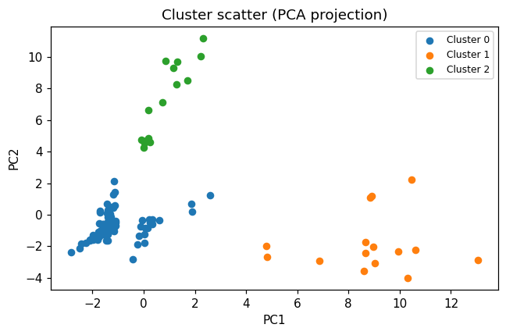
cluster scatter
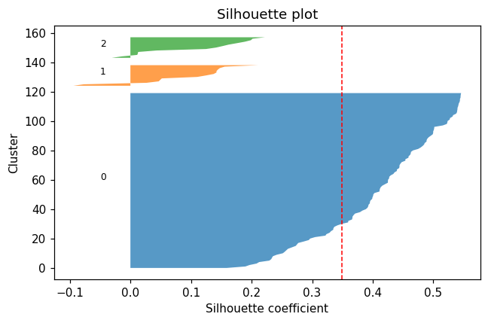
silhouette
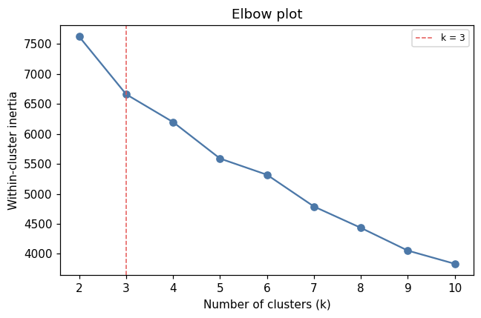
elbow

Method & Provenance
Metric | Value
method | Clustering — K-Means
engine | Python · scikit-learn 1.8.0
datasets | gallery — cat_g_proteomics_omics_only.csv
started | 2026-09-21 02:18:13.933986
permanent link | https://cat-g-omxpert.wishartlab.com/results/by-token/353bac72a0db47cbbc54087c03123afd
Parameter | Value
cluster_method | kmeans
feature_cols | Psat1g153760.1;Psat2g159360.1, Psat4g000800.1, Psat7g234480.1, Psat6g170320.2, P13918;Psat0s5g0160.1;Psat5g199920.1, Psat0s3063g0160.1, Psat0s1401g0040.1, Psat1g046920.1;Psat3g040960.1;Psat6g072360.3, Psat4g103520.1, A0A0K0KZR1, Psat0s1587g0080.1, D3VNE1;D3VNE2, Psat3g204960.1, Psat4g152760.1, Psat3g066960.1;Psat4g123280.1, Psat1g060840.1, Psat3g040960.1;Q04593, Psat4g095120.1, P82333, Psat0s2970g0080.1, Psat2g102880.1, Psat5g016560.1, Psat0s2008g0040.2;Psat1g060840.1, Psat1g141040.1;Psat1g141080.3, Psat2g028040.1, Psat2g036360.1;Psat2g036520.1, Psat5g111120.1, Psat1g136200.1, Psat1g046920.1;Psat3g040960.1, P19251, Q9SSY8, Psat1g107440.1;Psat2g149200.1;Psat4g184760.1;Psat4g185080.1, Psat6g235800.1;Psat6g235800.2, Psat2g036360.1;Psat2g036480.1;Psat2g036520.1, Q7M228, Q8LP17, Psat1g046920.1;Psat3g040960.1;Q04593, Psat1g107440.1;Psat4g184440.1, Psat1g046920.1;Psat3g040960.1;Psat6g182520.1;Q04593, Psat6g178400.1, A0A432N9M1, Psat6g054880.1, Psat4g213880.1, Psat2g036480.1, Psat7g102240.1, Psat0s1664g0080.1, Psat1g130000.1, A0A432NQN8, Psat3g094480.1, Psat1g046920.1;Psat3g040960.1;Psat6g072360.3;Psat6g182520.1, Psat3g197600.1, Q8VX19, Psat4g184440.1;Psat4g184760.1, Psat2g169200.1, Psat1g194520.1;Psat7g068160.1, Psat3g010120.1, Psat4g194120.1, Psat2g183320.1;Psat3g179120.1, Psat2g028440.1, P51082
n_clusters | 3

Command history
# python
from sklearn.cluster import KMeans
# python
labels = KMeans(n_clusters=3, n_init=10, random_state=42).fit_predict(X)
# python
silhouette = sklearn.metrics.silhouette_score(X, labels)

