Ordination Result #56 — Analysis Report
Generated 2026-09-21 02:39:22 · 1 run(s) · CAT-G Data Analyzer

1. ordination (#56)
2026-09-21 02:18:08 · ordination · status: completed
The first two PCA axes capture 58.6% of the total variance in the data.
Metric | Value
n_components | 3
method | pca
n_rows | 149
n_dropped | 0
color_col | Development_stage

explained variance
Axis | Fraction | Cumulative
Axis 1 | 0.38323 | 0.38323
Axis 2 | 0.203001 | 0.586231
Axis 3 | 0.099128 | 0.68536
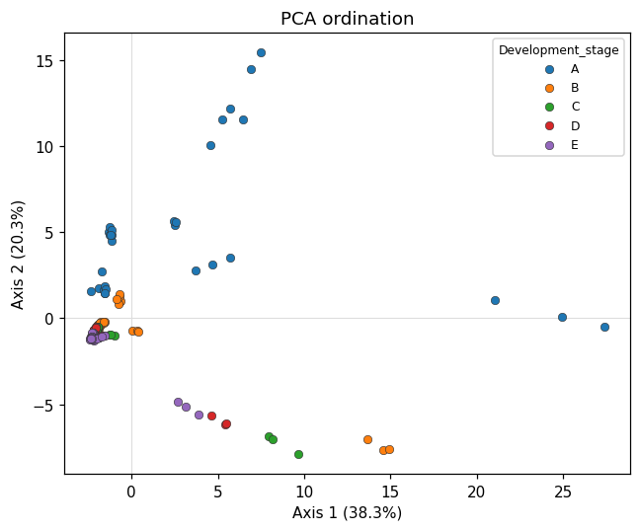
ordination scatter
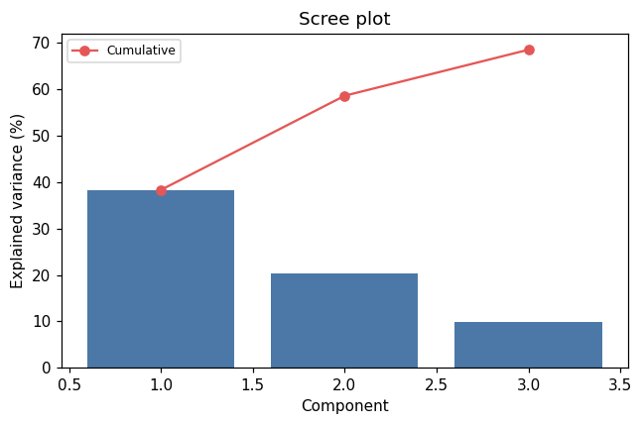
scree
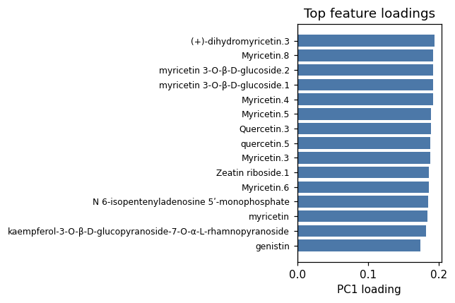
loadings

Method & Provenance
Metric | Value
method | Ordination — PCA
engine | Python · scikit-learn 1.8.0
datasets | gallery — cat_g_metabolomics_subset.csv
started | 2026-09-21 02:18:08.066263
permanent link | https://cat-g-omxpert.wishartlab.com/results/by-token/5b04a18a889d41b2a78dc32205a6aefe
Parameter | Value
ordination_method | pca
method | pca
feature_cols | Protein_content_pct, Days_after_flowering, Orientin.1, benzyladenine-9-N-glucoside, (+)-7-epi-12-hydroxy-12-oxojasmonoyl-L-isoleucine.17, apigenin.2, Soyasaponin III.2, (-)-epicatechin, Myricetin.5, N 6-isopentenyladenosine 5ʹ-monophosphate, (+)-epigallocatechin, Myricetin.6, Quercetin.3, (+)-6a-Hydroxymaackiain, (+)-dihydrokaempferol, Myricetin.3, Dihydromyricetin, genistin, glutathione, melatonin, (indol-3-yl)pyruvate.3, Myricetin.2, kaempferol-3-O-β-D-glucopyranoside-7-O-α-L-rhamnopyranoside, Myricetin.8, myricetin, (+)-dihydromyricetin.3, myricetin 3-O-β-D-glucoside.4, Myricetin.4, Epoxyroussoedione, Orientin, myricetin 3-O-β-D-glucoside.2, (+)-7-epi-12-hydroxyjasmonoyl-L-isoleucine.20, (Z)-ω-(methylsulfanyl)nonyl-thiohydroximate, epoxypheophorbide a.3, (+)-7-epi-12-oxojasmonoyl-L-isoleucine.18, myricetin 3-O-β-D-glucoside.5, (2R,3S,4S)-leucodelphinidin, (+)-taxifolin, myricetin 3-O-β-D-glucoside.1, 4-hydroxybenzoate, neophaseate.2, N-hydroxyhexahomomethioniate, quercetin.5, Kaempferol.1, indole-3-carbaldehyde.2, 3-(3,4-dihydroxyphenyl)pyruvate, a jasmonoyl-L-isoleucine.10, trans-zeatin, a jasmonoyl-L-isoleucine.11, Esculetin, (+)-7-epi-12-hydroxyjasmonoyl-L-isoleucine.22, (-)-epicatechin.2, (2-oxindol-3-yl)acetyl-L-aspartate.8, (+)-7-epi-12-hydroxyjasmonoyl-L-isoleucine.17, (+)-7-epi-12-hydroxy-12-oxojasmonoyl-L-isoleucine.13, Zeatin riboside.1, (-)-epigallocatechin, betulinic aldehyde.7, indole.2, (+)-taxifolin.1, gibberellin A53, (2-oxindol-3-yl)acetyl-L-aspartate.2
n_components | 3
color_col | Development_stage

Command history
# python
from sklearn.decomposition import PCA
# python
from sklearn.preprocessing import StandardScaler
# python
X_scaled = StandardScaler().fit_transform(X)
# python
coords = PCA(n_components=3).fit_transform(X_scaled)

