Gwas Result Result #29 — Analysis Report
Generated 2026-09-21 02:39:38 · 1 run(s) · CAT-G Data Analyzer

1. gwas result (#29)
2026-09-21 02:18:47 · gwas_result · status: completed
GWAS tested 8 SNPs after QC (of 20 input); 0 passed significance.
Metric | Value
n_snps_input | 20
n_snps_after_qc | 8
maf_filtered | 0
missingness_filtered | 0
hwe_filtered | 12
hwe_not_testable | 0
ld_pruned | 0
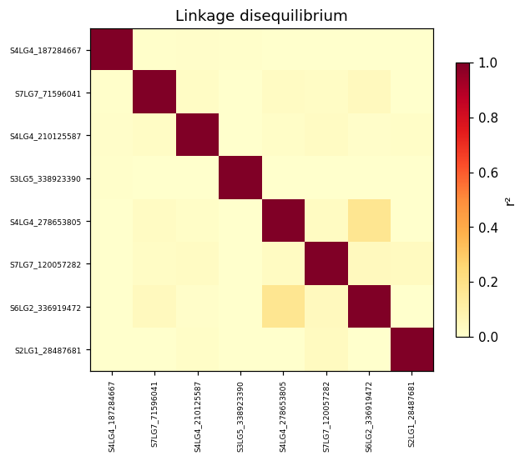
ld heatmap
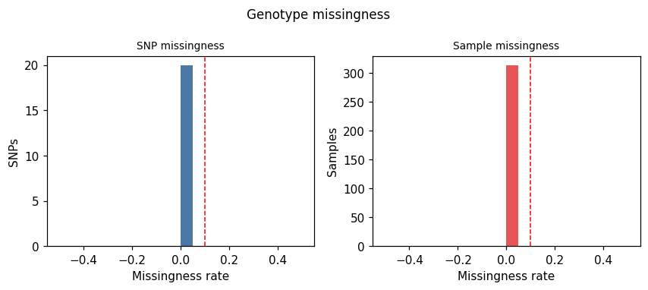
missingness plot
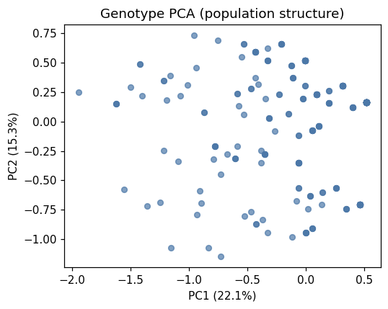
genotype pca

Method & Provenance
Metric | Value
method | GWAS — association analysis
engine | Python · scikit-learn/statsmodels 1.8.0
datasets | gallery — cat_g_gwas_real_data.csv
started | 2026-09-21 02:18:47.650556
permanent link | https://cat-g-omxpert.wishartlab.com/results/by-token/bb45ab95d37f40eb83d4d8e3b1980205
Parameter | Value
target_column | Protein_Y19
encoding_model | additive
significance_threshold | 0.00625
n_snps_input | 20
n_snps_after_qc | 8
n_samples | 283
n_significant | 0
lambda_gc | 33.578415

Command history
# python
# app.services.gwas_qc_service — SNP QC + allele encoding
# python
from sklearn.linear_model import LogisticRegression
# python
for snp in snp_matrix.columns: # per-SNP association test
# python
model = LogisticRegression(max_iter=1000).fit(X_snp, y)
# python
p = association_pvalue(model)
# python
fdr = statsmodels.stats.multitest.multipletests(p_values, method='fdr_bh')

