Random Forest Result #139 — Analysis Report
Generated 2026-09-21 02:35:52 · 1 run(s) · CAT-G Data Analyzer

1. random forest (#139)
2026-09-21 02:11:43 · random_forest · status: completed
The model explains 53.4% of the variance in the target under cross-validation.
Metric | Value
task_type | regression
r2_mean | 0.534495
r2_std | 0.020216
mse_mean | 40.124996
mse_std | 3.35536

permutation importance
name | mean | std
PLOT | 0.001104 | 0.001748
LAT | 0.00181 | 0.000957
LONG | 0.002725 | 0.002277
ENV_SOILNH4 | 0.002134 | 0.00171
ENV_SOILNO3 | 0.002311 | 0.003533
ENV_SOILP | 0.001566 | 0.003499
ENV_SOILOC | 0.016012 | 0.006552
ENV_SOILTN | 0.011141 | 0.012211
ENV_SOILTC | -0.000762 | 0.006243
ENV_PH | -0.002819 | 0.005171

shap importance
name | mean_abs
PLOT | 0.092551
LAT | 0.199099
LONG | 0.047196
ENV_SOILNH4 | 0.111703
ENV_SOILNO3 | 0.050621
ENV_SOILP | 0.06099
ENV_SOILOC | 0.221387
ENV_SOILTN | 0.734706
ENV_SOILTC | 0.240267
ENV_PH | 0.192217

split metrics
r2 | mse
0.562705 | 44.270396
0.516368 | 40.052147
0.52441 | 36.052445
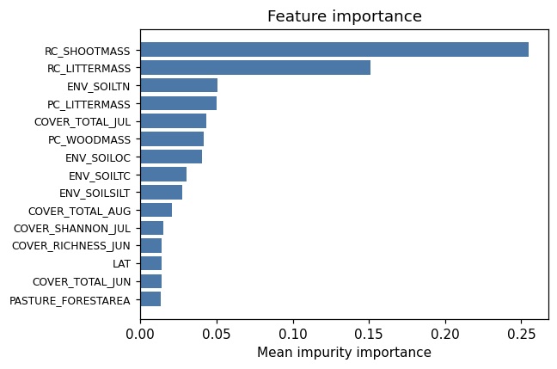
importance bar
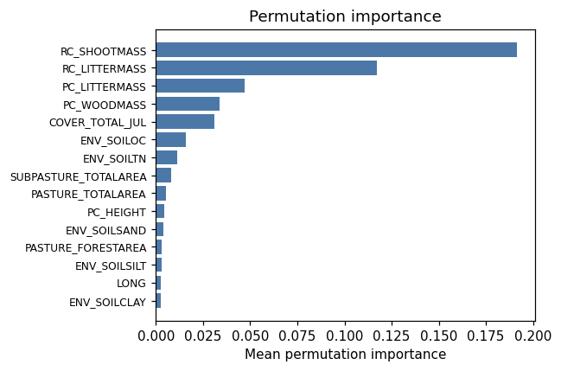
permutation bar
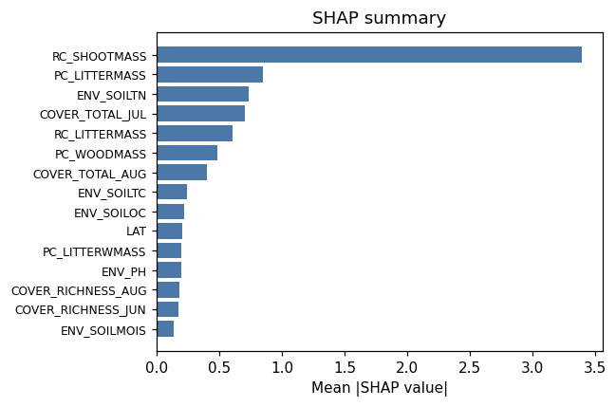
shap summary
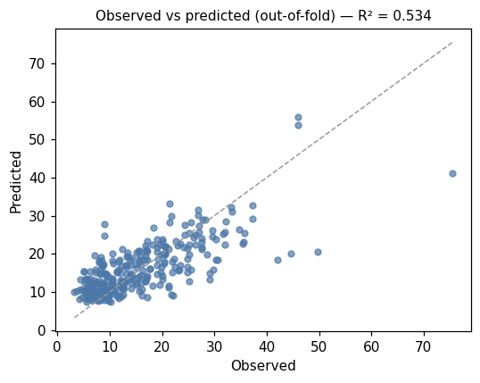
pred vs obs
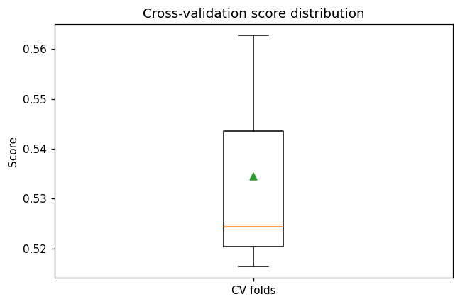
cv boxplot

Method & Provenance
Metric | Value
method | Random Forest (Regression)
engine | Python · scikit-learn 1.8.0
datasets | gallery — cat_g_field_data_plots.csv (preprocessed)
started | 2026-09-21 02:11:43.291308
permanent link | https://cat-g-omxpert.wishartlab.com/results/by-token/4ae9de70c16e41858d39d893714e9650
Parameter | Value
task_type | regression
model_type | regression
target_column | PC_SHOOTMASS
n_estimators | 60
n_splits | 3
test_size | 0.25
run_univariate | True
run_permutation | True
run_shap | True
permutation_repeats | 10
fdr_threshold | 0.05

Command history
# python
from sklearn.ensemble import RandomForestRegressor
# python
model = RandomForestRegressor(n_estimators=60, random_state=42)
# python
scores = sklearn.model_selection.cross_val_score(model, X, y, cv=3)

