Random Forest Result #140 — Analysis Report
Generated 2026-09-21 02:35:58 · 1 run(s) · CAT-G Data Analyzer

1. random forest (#140)
2026-09-21 02:12:05 · random_forest · status: completed
The classifier predicts the target with 100.0% cross-validated accuracy, weighted F1 1.000.
Metric | Value
task_type | classification
accuracy_mean | 1.0
accuracy_std | 0.0
f1_mean | 1.0
f1_std | 0.0
n_classes | 3

permutation importance
name | mean | std
PLOT | 0.0 | 0.0
LAT | 0.004667 | 0.0066
LONG | 0.011 | 0.004967
ENV_SOILNH4 | 0.0 | 0.0
ENV_SOILNO3 | 0.0 | 0.0
ENV_SOILP | 0.0 | 0.0
ENV_SOILOC | 0.004667 | 0.0066
ENV_SOILTN | 0.0 | 0.0
ENV_SOILTC | 0.0 | 0.0
ENV_PH | 0.0 | 0.0

shap importance
name | mean_abs
PLOT | 0.066248
LAT | 0.02633
LONG | 0.077888
ENV_SOILNH4 | 0.0
ENV_SOILNO3 | 0.000331
ENV_SOILP | 0.0
ENV_SOILOC | 0.013416
ENV_SOILTN | 0.01395
ENV_SOILTC | 0.013066
ENV_PH | 0.0

split metrics
accuracy | f1_weighted
1.0 | 1.0
1.0 | 1.0
1.0 | 1.0
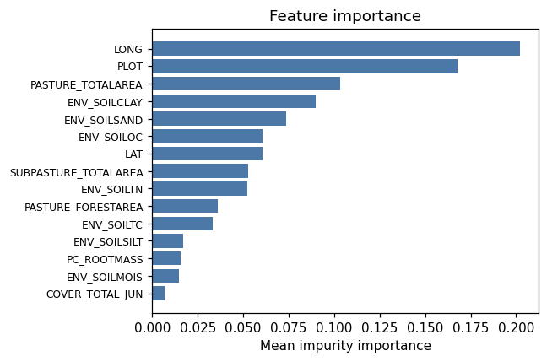
importance bar
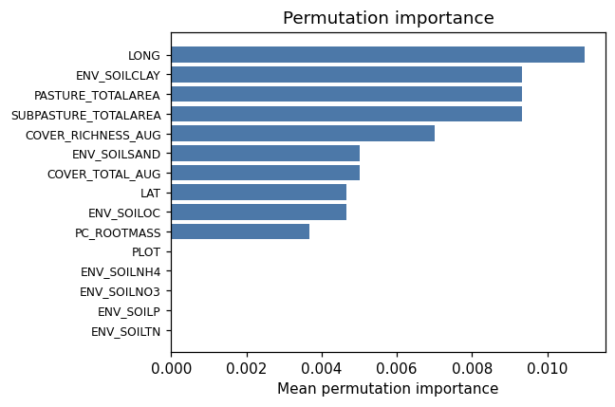
permutation bar
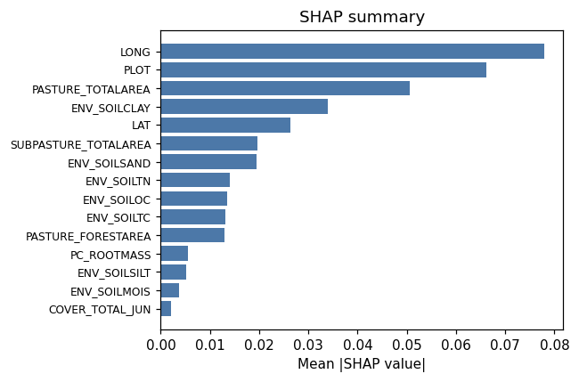
shap summary
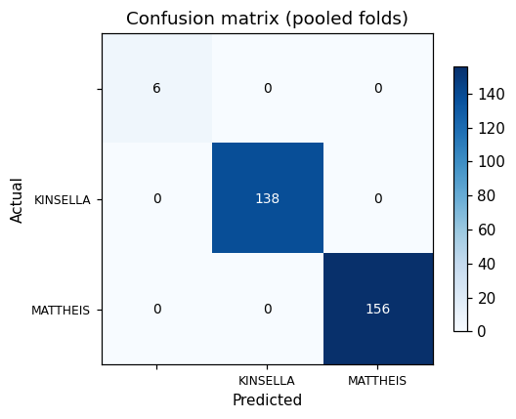
confusion heatmap
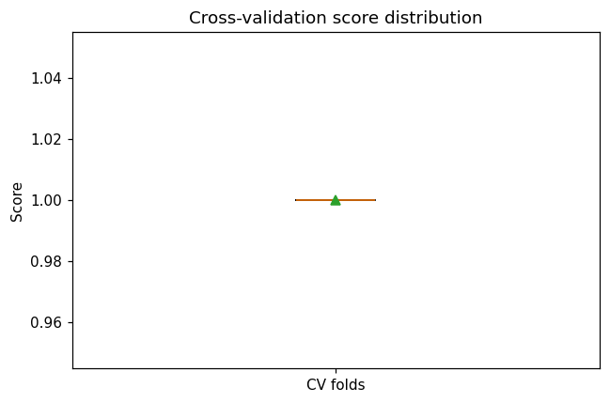
cv boxplot

Method & Provenance
Metric | Value
method | Random Forest (Classification)
engine | Python · scikit-learn 1.8.0
datasets | gallery — cat_g_field_data_plots.csv
started | 2026-09-21 02:12:05.989988
permanent link | https://cat-g-omxpert.wishartlab.com/results/by-token/76d644e54c38460abc9ca6f21474ff98
Parameter | Value
task_type | classification
model_type | classification
target_column | RANCH
n_estimators | 60
n_splits | 3
test_size | 0.25
run_univariate | True
run_permutation | True
run_shap | True
permutation_repeats | 10
fdr_threshold | 0.05

Command history
# python
from sklearn.ensemble import RandomForestClassifier
# python
model = RandomForestClassifier(n_estimators=60, random_state=42)
# python
scores = sklearn.model_selection.cross_val_score(model, X, y, cv=3)

