Random Forest Result #138 — Analysis Report
Generated 2026-09-21 02:35:40 · 1 run(s) · CAT-G Data Analyzer

1. random forest (#138)
2026-09-21 02:11:08 · random_forest · status: completed
The model explains 54.4% of the variance in the target under cross-validation.
Metric | Value
task_type | regression
r2_mean | 0.544146
r2_std | 0.01283
mse_mean | 39.370091
mse_std | 4.061467

permutation importance
name | mean | std
PLOT | 0.000306 | 0.000724
LAT | 0.007732 | 0.001774
LONG | 0.001503 | 0.00154
ENV_SOILNH4 | 0.003629 | 0.002743
ENV_SOILNO3 | -0.000594 | 0.002811
ENV_SOILP | 0.000928 | 0.00248
ENV_SOILOC | 0.01288 | 0.008753
ENV_SOILTN | 0.011657 | 0.002143
ENV_SOILTC | 0.00416 | 0.007555
ENV_PH | -0.002956 | 0.00333

shap importance
name | mean_abs
PLOT | 0.086385
LAT | 0.241393
LONG | 0.050582
ENV_SOILNH4 | 0.09909
ENV_SOILNO3 | 0.068239
ENV_SOILP | 0.055237
ENV_SOILOC | 0.104043
ENV_SOILTN | 0.720728
ENV_SOILTC | 0.300837
ENV_PH | 0.173977

split metrics
r2 | mse
0.559827 | 44.486553
0.528399 | 39.072311
0.544211 | 34.551409
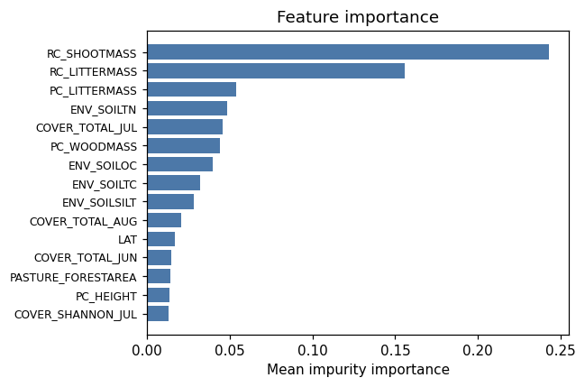
importance bar
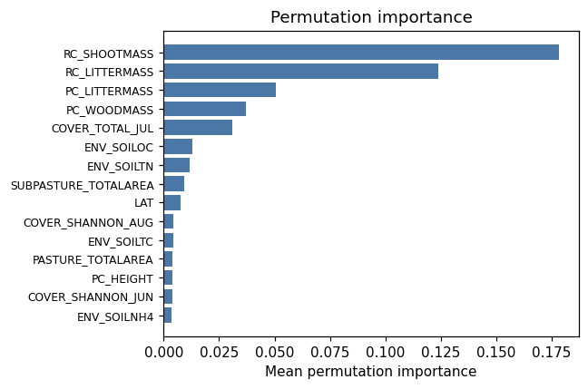
permutation bar
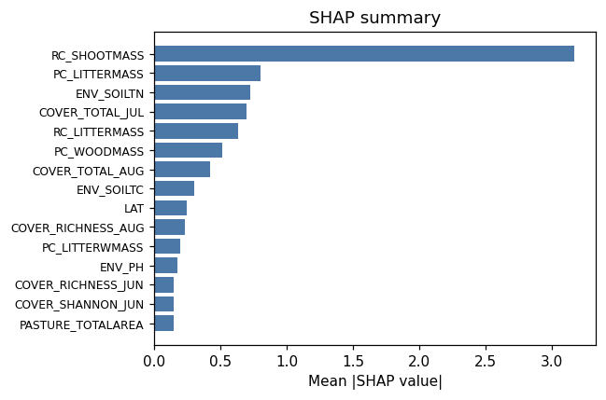
shap summary
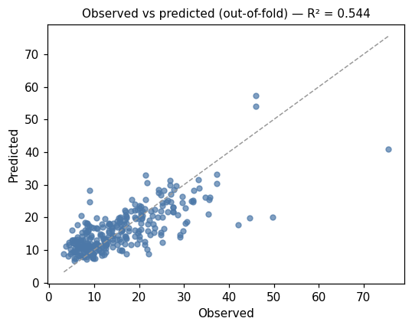
pred vs obs
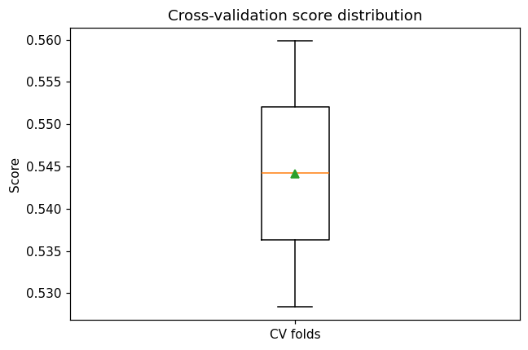
cv boxplot

Method & Provenance
Metric | Value
method | Random Forest (Regression)
engine | Python · scikit-learn 1.8.0
datasets | gallery — cat_g_field_data_plots.csv
started | 2026-09-21 02:11:08.707331
permanent link | https://cat-g-omxpert.wishartlab.com/results/by-token/e38fdc04752c42c5a01d7772f67245f3
Parameter | Value
task_type | regression
model_type | regression
target_column | PC_SHOOTMASS
n_estimators | 60
n_splits | 3
test_size | 0.25
run_univariate | True
run_permutation | True
run_shap | True
permutation_repeats | 10
fdr_threshold | 0.05

Command history
# python
from sklearn.ensemble import RandomForestRegressor
# python
model = RandomForestRegressor(n_estimators=60, random_state=42)
# python
scores = sklearn.model_selection.cross_val_score(model, X, y, cv=3)

