Preprocessing Result #34 — Analysis Report
Generated 2026-09-21 02:35:46 · 1 run(s) · CAT-G Data Analyzer

1. preprocessing (#34)
2026-09-21 02:11:20 · preprocessing · status: completed
Preprocessing transformed the dataset from 400 rows to 400 rows with 40 output features.
Metric | Value
n_rows_in | 400
n_rows_out | 400
n_features_out | 40
target_col | PC_SHOOTMASS
derived_dataset_id | 691
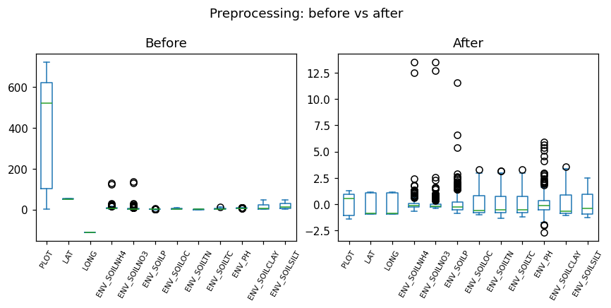
before after boxplot
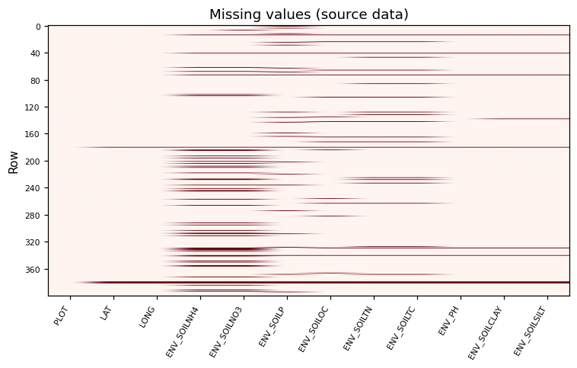
missingness heatmap

Method & Provenance
Metric | Value
method | Preprocessing
engine | Python · pandas/scikit-learn 3.0.3
datasets | gallery — cat_g_field_data_plots.csv
started | 2026-09-21 02:11:20.564609
permanent link | https://cat-g-omxpert.wishartlab.com/results/by-token/eb7eb2770d9b4a1cbd47e9bc2da501e5
Parameter | Value
normalization | {'method': 'z-score'}
steps | missing_value_imputation → normalization

Command history
# python
# app.services.preprocessing_service.PreprocessingService
# python
# step: missing_value_imputation
# python
# step: normalization
# python
df_out = service.apply(df, steps=steps, params=params)

