Ordination Result #49 — Analysis Report
Generated 2026-09-21 02:36:16 · 1 run(s) · CAT-G Data Analyzer

1. ordination (#49)
2026-09-21 02:12:39 · ordination · status: completed
The first two PCA axes capture 31.4% of the total variance in the data.
Metric | Value
n_components | 3
method | pca
n_rows | 59
n_dropped | 341
color_col | RANCH

explained variance
Axis | Fraction | Cumulative
Axis 1 | 0.189909 | 0.189909
Axis 2 | 0.123726 | 0.313636
Axis 3 | 0.10144 | 0.415075
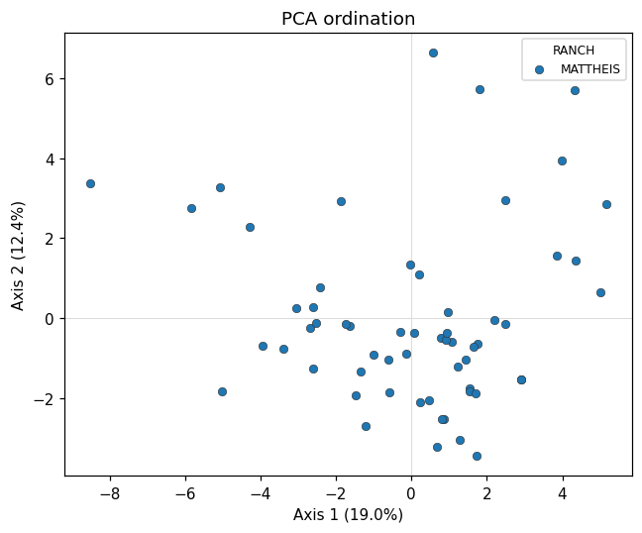
ordination scatter
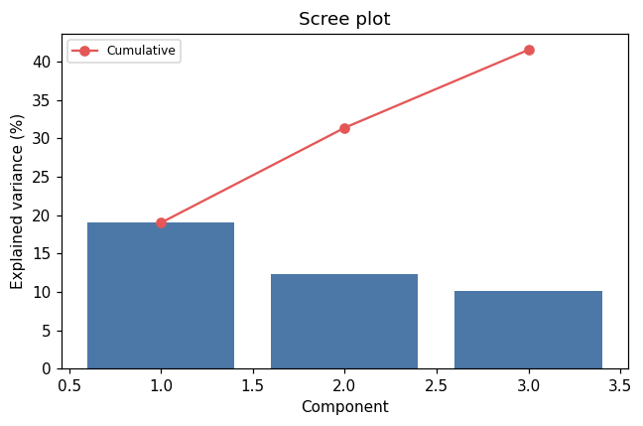
scree
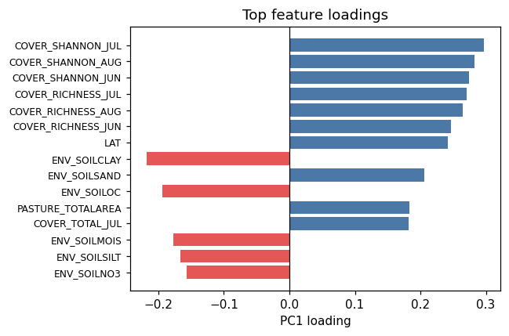
loadings

Warnings
- Excluded identifier-like numeric column(s): PLOT. These look like bookkeeping fields rather than measurements. Select feature columns explicitly if you intended to include them.

Method & Provenance
Metric | Value
method | Ordination — PCA
engine | Python · scikit-learn 1.8.0
datasets | gallery — cat_g_field_data_plots.csv
started | 2026-09-21 02:12:39.328469
permanent link | https://cat-g-omxpert.wishartlab.com/results/by-token/ba8cd7e8395a46ef8ddbbc2497cfc4f5
Parameter | Value
ordination_method | pca
method | pca
feature_cols | LAT, LONG, ENV_SOILNH4, ENV_SOILNO3, ENV_SOILP, ENV_SOILOC, ENV_SOILTN, ENV_SOILTC, ENV_PH, ENV_SOILCLAY, ENV_SOILSILT, ENV_SOILSAND, ENV_SOILMOIS, RC_SHOOTMASS, RC_WOODMASS, RC_LITTERMASS, RC_LITTERWMASS, PC_SHOOTMASS, PC_WOODMASS, PC_LITTERMASS, PC_LITTERWMASS, PC_ROOTMASS, PC_HEIGHT, GH_COUNT, ENV_AIRTEMP, COVER_RICHNESS_JUN, COVER_TOTAL_JUN, COVER_SHANNON_JUN, COVER_RICHNESS_JUL, COVER_TOTAL_JUL, COVER_SHANNON_JUL, COVER_RICHNESS_AUG, COVER_TOTAL_AUG, COVER_SHANNON_AUG, PASTURE_TOTALAREA, SUBPASTURE_TOTALAREA, PASTURE_FORESTAREA, PASTURE_WETLANDAREA, SUBPASTURE_FORESTAREA, SUBPASTURE_WETLANDAREA
n_components | 3
color_col | RANCH

Command history
# python
from sklearn.decomposition import PCA
# python
from sklearn.preprocessing import StandardScaler
# python
X_scaled = StandardScaler().fit_transform(X)
# python
coords = PCA(n_components=3).fit_transform(X_scaled)

