Correlation Result #108 — Analysis Report
Generated 2026-09-21 02:36:09 · 1 run(s) · CAT-G Data Analyzer

1. correlation (#108)
2026-09-21 02:12:25 · correlation · status: completed
The strongest correlation is between LAT and LONG (r = 0.999, positive).
Metric | Value
n_pairs_tested | 780
n_significant_fdr_05 | 332
fdr_method | Benjamini-Hochberg
title | Correlation matrix
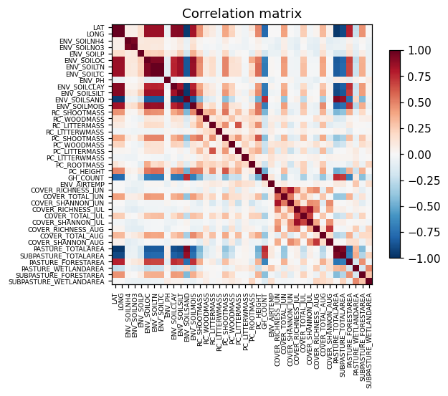
correlation heatmap
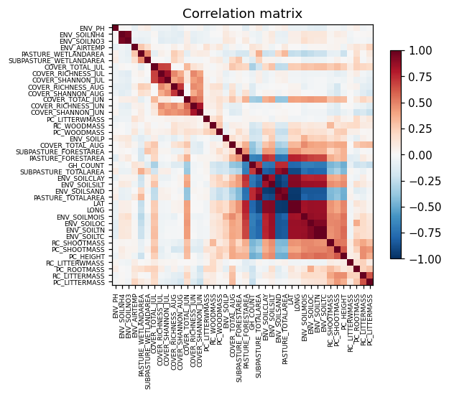
correlation clustered

Warnings
- Excluded identifier-like numeric column(s): PLOT. These look like bookkeeping fields rather than measurements and were left out of the correlation matrix.

Method & Provenance
Metric | Value
method | Pearson correlation
engine | Python · pandas/scipy 1.17.1
datasets | gallery — cat_g_field_data_plots.csv
started | 2026-09-21 02:12:25.478747
permanent link | https://cat-g-omxpert.wishartlab.com/results/by-token/326b3d0fdd824485b8bbf289d288befe
Parameter | Value
method | pearson

Command history
# python
corr = df.corr(method='pearson')
# python
from scipy import stats
# python
r, p = stats.pearsonr(x, y) # per pair
# python
q = statsmodels.stats.multitest.multipletests(p_values, method='fdr_bh')

