Clustering Result #32 — Analysis Report
Generated 2026-09-21 02:36:19 · 1 run(s) · CAT-G Data Analyzer

1. kmeans (#32)
2026-09-21 02:12:45 · clustering · status: completed
Clustering split 59 samples into 3 clusters (mean silhouette 0.152).
Metric | Value
method | kmeans
k | 3
silhouette | 0.152473
n_rows | 59
n_dropped | 341
derived_dataset_id | 693

sizes
name | value
0 | 9
1 | 35
2 | 15

inertia sweep
name | value
2 | 2093.887449
3 | 1847.72523
4 | 1699.257911
5 | 1613.733829
6 | 1523.590748
7 | 1408.770415
8 | 1339.767584
9 | 1255.414151
10 | 1173.445572
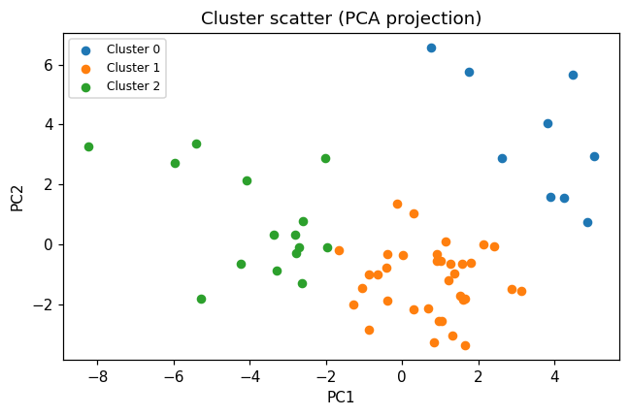
cluster scatter
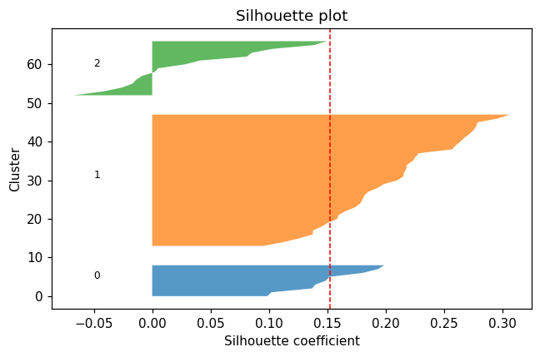
silhouette
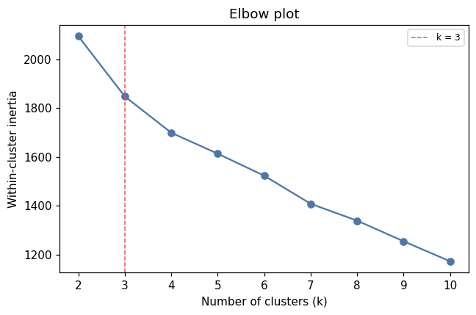
elbow

Method & Provenance
Metric | Value
method | Clustering — K-Means
engine | Python · scikit-learn 1.8.0
datasets | gallery — cat_g_field_data_plots.csv
started | 2026-09-21 02:12:45.307195
permanent link | https://cat-g-omxpert.wishartlab.com/results/by-token/a038a07d3c7e4e02ab3ee272769ecd2c
Parameter | Value
cluster_method | kmeans
feature_cols | PLOT, LAT, LONG, ENV_SOILNH4, ENV_SOILNO3, ENV_SOILP, ENV_SOILOC, ENV_SOILTN, ENV_SOILTC, ENV_PH, ENV_SOILCLAY, ENV_SOILSILT, ENV_SOILSAND, ENV_SOILMOIS, RC_SHOOTMASS, RC_WOODMASS, RC_LITTERMASS, RC_LITTERWMASS, PC_SHOOTMASS, PC_WOODMASS, PC_LITTERMASS, PC_LITTERWMASS, PC_ROOTMASS, PC_HEIGHT, GH_COUNT, ENV_AIRTEMP, COVER_RICHNESS_JUN, COVER_TOTAL_JUN, COVER_SHANNON_JUN, COVER_RICHNESS_JUL, COVER_TOTAL_JUL, COVER_SHANNON_JUL, COVER_RICHNESS_AUG, COVER_TOTAL_AUG, COVER_SHANNON_AUG, PASTURE_TOTALAREA, SUBPASTURE_TOTALAREA, PASTURE_FORESTAREA, PASTURE_WETLANDAREA, SUBPASTURE_FORESTAREA, SUBPASTURE_WETLANDAREA
n_clusters | 3

Command history
# python
from sklearn.cluster import KMeans
# python
labels = KMeans(n_clusters=3, n_init=10, random_state=42).fit_predict(X)
# python
silhouette = sklearn.metrics.silhouette_score(X, labels)

